FUNDAMETAL OF BLOCKCHAIN

Introduction of web1 vs web2 vs web3

In this class you learn about basic of introduction web1 vs web2 vs web3

Web1.o vs web2.o vs web3.o

* Web1.o(1998-2005): read only
* Web2.o(2005-present): read and write
* Web3.o(yet to come): read write own

WEB 1.O

Web 1.0 is the term used for the earliest version of the Internet as it emerged from its origins with Defense Advanced Research Projects Agency (DARPA) and became, for the first time, a global network representing the future of digital communications.

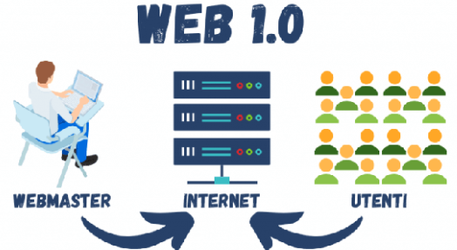

Web 1.0 refers to the early days of the World Wide Web, starting from its inception in 1989 until the mid-1990s. During this time, the web was primarily a collection of static HTML pages with limited interactivity and user participation. Websites were primarily used to display information, and users could only consume content, not contribute to it.

Some characteristics of Web 1.0 include:

1. Static content: Websites were composed of static HTML pages that were designed to be read-only.
2. Limited interactivity: There was little or no interactivity on websites. Users could not interact with the content, except for clicking on links to move from one page to another.
3. Basic design: Websites were typically simple in design, with plain text and basic graphics.
4. Slow connection speeds: Connection speeds were slow during this time, so websites were designed to be lightweight and load quickly.
5. Limited e-commerce: E-commerce was not widespread during Web 1.0. There were very few online stores, and those that did exist were basic in design and functionality.

Overall, Web 1.0 was a transitional period in the development of the World Wide Web, laying the foundation for the more interactive and dynamic web we know today as Web 2.0.

Top of Form

Regenerate response

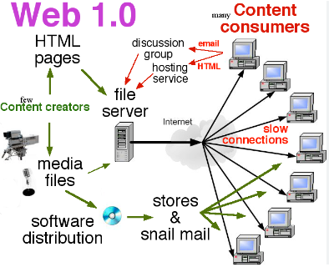

Example of web1.o-

* static page
* html form send in via email
* content for the service file system rather than a data base management system
* GIF buttons and graphics

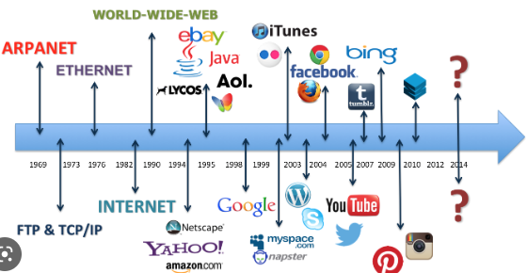

Web 1.0 technologies refer to the technologies used during the early days of the World Wide Web, from its inception in 1989 until the mid-1990s. During this time, websites were primarily composed of static HTML pages that were designed to be read-only, with limited interactivity and user participation. Some of the key technologies used during this period include:





What is Web 2.o-

Web 2.0 refers to a transition in the World Wide Web from static, read-only web pages to dynamic, interactive, and user-generated content. The term was coined in the early 2000s, and Web 2.0 represents a significant shift in the way people use and interact with the web.

Some of the characteristics of Web 2.0 include:

1. User-generated content: Web 2.0 sites are designed to allow users to create, share, and interact with content. Examples include social media platforms, blogs, and wikis.
2. Social networking: Web 2.0 sites are built around social networking features that enable users to connect with one another, share content, and collaborate.
3. Rich internet applications: Web 2.0 technologies have enabled the creation of rich internet applications that are interactive, responsive, and dynamic. Examples include online games, video streaming, and web-based productivity tools.
4. Web services: Web 2.0 sites use web services to exchange data and functionality with other sites and applications. This allows for greater interoperability and seamless integration between different platforms.
5. Mobile computing: With the rise of mobile devices, Web 2.0 sites have become increasingly optimized for mobile use, with responsive design and mobile apps.

Overall, Web 2.0 represents a shift towards a more collaborative, user-centric web that allows for greater participation and interaction.

Top of Form

Regenerate response



Example of web 2.o-

Sure, here are some examples of Web 2.0 features:

1. Social networking sites: Web 2.0 introduced the concept of social networking, where users could connect and interact with one another. Examples include Facebook, Twitter, LinkedIn, and Instagram.
2. Blogs: Web 2.0 made it easy for users to create their own blogs and share their thoughts, ideas, and experiences with others. Popular blogging platforms include WordPress, Blogger, and Medium.
3. Wikis: Wikis are collaborative websites that allow users to create, edit, and share content. Examples include Wikipedia, Wikia, and Fandom.
4. Online productivity tools: Web 2.0 brought about a range of online productivity tools that allow users to collaborate on documents, spreadsheets, and presentations in real-time. Examples include Google Docs, Microsoft Office Online, and Zoho.
5. Multimedia sharing platforms: Web 2.0 introduced a range of multimedia sharing platforms that allow users to upload, share, and view photos, videos, and other media. Examples include YouTube, Flickr, and Vimeo.
6. E-commerce websites: Web 2.0 brought about a new generation of e-commerce websites that made online shopping more convenient and user-friendly. Examples include Amazon, eBay, and Etsy.
7. Web applications: Web 2.0 made it possible to build and use web applications that function like traditional desktop applications, but are accessible through a web browser. Examples include Google Maps, Dropbox, and Trello.

These are just a few examples of how Web 2.0 has transformed the World Wide Web, making it more interactive, collaborative, and user-friendly.

Top of Form

Regenerate response



Feature of web 2.o-

Web 2.0 refers to a second generation of web-based services and applications that emphasize user-generated content, collaboration, and social networking. The main features of Web 2.0 include:

1. User-generated content: Web 2.0 applications allow users to create, share, and collaborate on content, such as blogs, wikis, and social media platforms.
2. Social networking: Web 2.0 applications are designed to foster social connections and facilitate communication and collaboration among users.
3. Rich internet applications: Web 2.0 applications make use of advanced technologies, such as AJAX, to create more dynamic and interactive user interfaces.
4. Collaboration and sharing: Web 2.0 applications allow users to collaborate on projects, share files, and communicate with each other in real-time.
5. Personalization: Web 2.0 applications allow users to customize their experience based on their interests, preferences, and behaviors.

Overall, the main feature of Web 2.0 is its emphasis on user-generated content, social networking, and collaboration, which have transformed the way people interact with each other and with online content.

Top of Form



Web 3.o-

Web 3.0, also known as the Semantic Web or the Decentralized Web, is the next generation of the World Wide Web, which aims to make the internet more intelligent, interconnected, and decentralized. The key features of Web 3.0 include:

1. Decentralization: Web 3.0 aims to create a more decentralized internet by using blockchain technology and peer-to-peer networks. This allows for greater privacy, security, and control over personal data.
2. Artificial Intelligence: Web 3.0 uses machine learning and natural language processing to create intelligent applications that can understand and interpret data more accurately.
3. Semantic Web: Web 3.0 makes use of metadata and other structured data to create a more interconnected web, where data can be easily shared and understood by machines.
4. Personalization: Web 3.0 aims to provide users with a more personalized experience by using machine learning algorithms to analyze user data and deliver personalized content and recommendations.
5. Internet of Things: Web 3.0 aims to connect all devices and objects to the internet, allowing for greater automation and control over physical systems.

Overall, the goal of Web 3.0 is to create a more intelligent, decentralized, and interconnected web that empowers users and provides greater control over personal data.

Top of Form

Regenerate response



Example of web 3.0-

There are several examples of Web 3.0 technologies and applications that are currently being developed and deployed. Here are a few examples:

1. Blockchain-based platforms: Blockchain technology is a key component of Web 3.0, and there are several blockchain-based platforms that are being developed for various use cases, such as decentralized finance (DeFi), supply chain management, and social networks. Examples include Ethereum, Polkadot, and Solana.
2. Decentralized social networks: Decentralized social networks are being developed as an alternative to centralized social media platforms, which have been criticized for their lack of privacy and censorship. Examples include Mastodon, Diaspora, and Minds.
3. Decentralized file storage: Decentralized file storage platforms are being developed to provide a more secure and private alternative to centralized cloud storage services. Examples include IPFS, Sia, and Storj.
4. Decentralized marketplaces: Decentralized marketplaces are being developed to enable peer-to-peer transactions without intermediaries. Examples include Open Bazaar and Origin Protocol.
5. AI-powered personal assistants: AI-powered personal assistants are being developed to provide more personalized and intelligent interactions with users. Examples include Mycroft and Snips.

Overall, Web 3.0 is still in its early stages of development, but there are many exciting technologies and applications that are being built to create a more decentralized, intelligent, and interconnected web.



There are several examples of Web 3.0 technologies and applications that are currently being developed and deployed. Here are a few examples:

Feature of web 3.o technology

include Web 3.0 technologies are designed to create a more decentralized, intelligent, and interconnected web. Some of the key features of Web 3.0 technology:

1. Decentralization: Web 3.0 technologies are based on decentralized architectures, which enable greater security, privacy, and control over personal data. Decentralized systems use peer-to-peer networks and Blockchain technology to eliminate the need for centralized intermediaries, reducing the risk of data breaches and censorship.
2. Interoperability: Web 3.0 technologies aim to create a more interconnected web, where data

Top of Form

Stop generating

Bottom of Form

### 

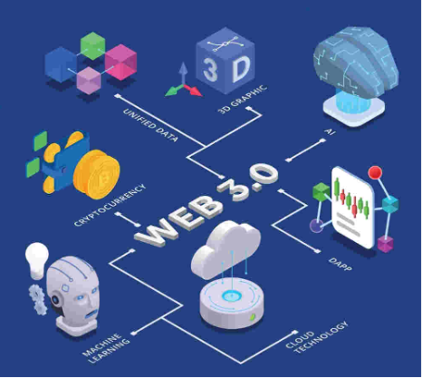

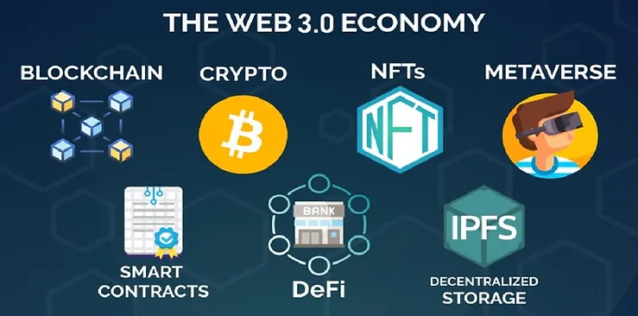

**The Transition from Web 2.o To Web 3.o-**

In this class you’ll learn about transition from web 2.o to web 3.o

Transition from web2.o to web3.o

Web 3.0 technologies are designed to create a more decentralized, intelligent, and interconnected web. Some of the key features of Web 3.0 technology include:

1. Decentralization: Web 3.0 technologies are based on decentralized architectures, which enable greater security, privacy, and control over personal data. Decentralized systems use peer-to-peer networks and blockchain technology to eliminate the need for centralized intermediaries, reducing the risk of data breaches and censorship.
2. Interoperability: Web 3.0 technologies aim to create a more interconnected web, where data and applications can be easily shared and used across different platforms and networks. This is achieved through the use of open standards and protocols, such as the Semantic Web and the Inter Planetary File System (IPFS).
3. Artificial Intelligence: Web 3.0 technologies make use of machine learning, natural language processing, and other AI technologies to create more intelligent applications that can understand and interpret data more accurately. AI-powered systems can provide more personalized and relevant content and services, improving the user experience.
4. Smart Contracts: Web 3.0 technologies make use of smart contracts, which are self-executing contracts with the terms of the agreement between buyer and seller being directly written into lines of code. Smart contracts enable trust less, automated transactions, reducing the need for intermediaries and enabling greater efficiency and transparency in business processes.
5. Cryptography: Web 3.0 technologies rely heavily on cryptography, which provides the basis for secure and private communications, data storage, and transactions. Cryptography is used to encrypt data, verify identities, and protect against fraud and other forms of cybercrime.

Overall, Web 3.0 technologies are designed to create a more decentralized, intelligent, and secure web that empowers users and provides greater control over personal data.

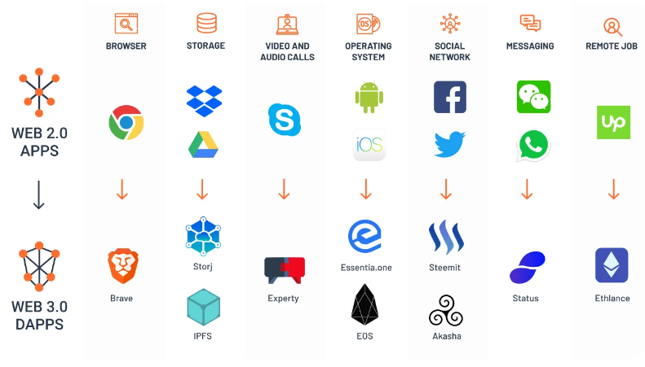

**Centralized vs decentralized and distributed network-**

In this assignment we are going to study about centralized and decentralized and distributed network

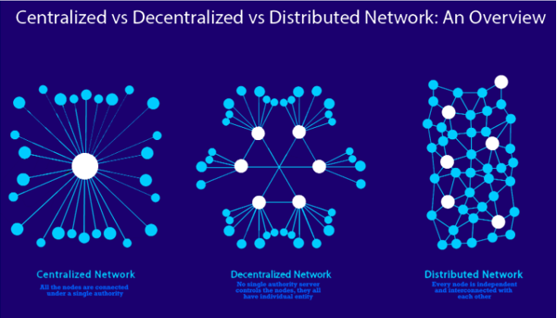

**Centralized network**

1. Single point of control: Centralized networks rely on a central server or hub that acts as a single point of control for the entire network. This central authority has the power to make decisions, enforce rules, and manage access to data and resources.
2. Centralized data storage: In a centralized network, all data is stored on the central server or hub. This can lead to issues with data privacy and security, as a single point of failure or attack could compromise the entire network.
3. Limited scalability: Centralized networks can be limited in their ability to scale, as all communication between nodes must pass through the central server. This can result in bottlenecks and latency issues, particularly in large networks with a high volume of traffic.
4. Reliance on infrastructure: Centralized networks are heavily reliant on the underlying infrastructure, such as servers, routers, and switches. A failure or outage in the infrastructure can bring down the entire network.
5. Lack of transparency: In a centralized network, the central authority has complete control over the network, which can lead to a lack of transparency and accountability. Users may not have access to information about how their data is being used or how decisions are being made.
6. Despite these limitations, centralized networks can offer benefits such as ease of use, reliability, and centralized control. However, the rise of decentralized technologies such as blockchain and peer-to-peer networks is challenging the dominance of centralized networks, and may offer a more secure, transparent, and scalable alternative.

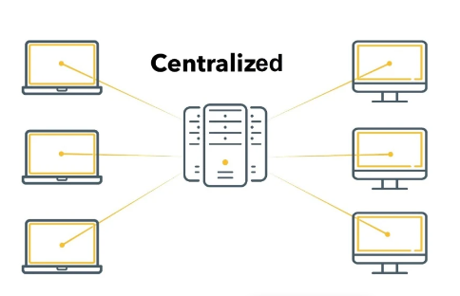

Decentralized network-

* A decentralized network is a type of computer network architecture in which multiple nodes or computers work together to achieve a common goal without the need for a central authority or control. Here are some key points about decentralized networks:
* Decentralized networks are distributed systems where there is no single point of control or failure.
* In a decentralized network, all nodes are equal and work together to perform tasks or provide services.
* Decentralized networks can be more resilient and secure as there is no single point of failure or attack.
* Blockchain technology is an example of a decentralized network, where transactions are validated and recorded across multiple nodes.
* Decentralized networks can also be used for peer-to-peer file sharing, content delivery, and communication.
* Decentralized networks can help to promote privacy and anonymity, as there is no central entity that can collect or monitor data.
* In some cases, decentralized networks can be slower or less efficient than centralized networks due to the need for nodes to communicate and coordinate with each other.
* Decentralized networks can also pose challenges in terms of governance, decision-making, and scalability.
* Top of Form

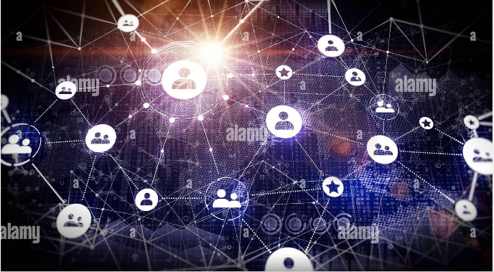

Distributed network-

A distributed network is a type of computer network architecture where computing tasks or data processing are spread out across multiple nodes or computers. Here are some key points about distributed networks:

1. Distributed networks can be thought of as a subset of decentralized networks where tasks or data processing is distributed across nodes in a more specific way.
2. In a distributed network, nodes communicate with each other and share resources to complete tasks or process data.
3. Distributed networks can be more scalable than centralized networks as tasks can be distributed across multiple nodes, allowing for more processing power and bandwidth.
4. Peer-to-peer file sharing, content distribution networks, and cloud computing are examples of distributed networks.
5. In a distributed network, nodes can fail or leave the network without affecting the overall system's performance, as other nodes can take over their tasks.
6. Distributed networks can also be more resilient and secure as there is no single point of failure or attack.
7. However, distributed networks can also pose challenges in terms of governance, data consistency, and data synchronization, as data may need to be distributed and synchronized across multiple nodes.
8. Distributed networks can also require more complex network protocols and algorithms to ensure efficient communication and coordination between nodes.

Top of Form

What is Blockchain

in this assignment we are going to study about Blockchain

* Blockchain is a decentralized digital ledger technology that enables secure, transparent, and tamper-proof record-keeping of transactions and data.
* It is a type of distributed database that stores information across a network of computers or nodes.
* Transactions and data are grouped together into blocks, which are cryptographically linked to each other in a chronological chain, creating an immutable record of the information.
* Each block contains a unique digital signature or hash that verifies its authenticity and prevents tampering with the data.
* Blockchain technology is best known for its use in cryptocurrencies such as Bitcoin, but it can also be applied to other industries such as supply chain management, healthcare, and voting systems.
* Blockchain can provide increased security and transparency in transactions by eliminating the need for a central authority or middleman to verify and process transactions.
* The decentralized nature of blockchain means that there is no single point of failure, making it more resilient to cyberattacks and system failures.
* Blockchain technology can also provide greater privacy and control over personal data by allowing users to maintain ownership and control over their data.
* However, blockchain technology can also face challenges in terms of scalability, energy consumption, and regulatory compliance.
* Blockchain is a promising technology with a wide range of potential applications, but it is still in its early stages and requires further development and refinement.
* Top of Form



Components of Blockchain DLF technology-

The components of blockchain distributed ledger technology (DLT) typically include the following:

1. Nodes: These are the computers or devices that participate in the blockchain network. Each node has a copy of the ledger and can validate transactions and add blocks to the chain.
2. Blocks: These are groups of transactions that are verified and added to the blockchain. Each block contains a unique cryptographic hash that links it to the previous block, creating an immutable and tamper-proof chain of blocks.
3. Consensus protocol: This is a set of rules and algorithms that enable nodes in the network to agree on the state of the blockchain ledger. Consensus is critical to maintaining the integrity of the blockchain, as it ensures that all nodes have the same copy of the ledger and that any changes are agreed upon by the network.
4. Smart contracts: These are self-executing contracts that are stored on the blockchain and can automatically enforce the terms of an agreement between two parties. Smart contracts can be programmed to execute automatically when certain conditions are met, reducing the need for intermediaries and increasing the efficiency and security of transactions.
5. Cryptography: This is the use of mathematical algorithms to secure transactions and data on the blockchain. Cryptography is used to create digital signatures, hash functions, and other cryptographic protocols that ensure the authenticity and integrity of data on the blockchain.

Overall, these components work together to create a secure, transparent, and decentralized system for recording and verifying transactions and data on the blockchain.

Top of Form



Hashing algorithm

In this class we are going to study about crypto graphically

**Crypto graphically secured hashing algorithm**

As I mentioned earlier, a hashing algorithm is a mathematical function that takes an input and produces a fixed-size output (also known as a hash or message digest). A cryptographic hashing algorithm is a type of hashing algorithm that is designed to be secure and resistant to attacks.

Cryptographic hashing algorithms are widely used in cryptography and computer security to ensure the confidentiality, integrity, and authenticity of data. They are used in a variety of applications, including digital signatures, password storage, and data verification.

Some examples of cryptographic hashing algorithms include:

* SHA-256 (Secure Hash Algorithm 256-bit)
* SHA-3 (Secure Hash Algorithm 3)
* BLAKE2 (an improved version of BLAKE)
* Scrypt (a key derivation function used in password-based key derivation)
* Argon2 (a password-hashing algorithm designed to be resistant to brute-force attacks)

When selecting a hashing algorithm, it is important to consider factors such as the level of security required, the size of the input data, and the computational resources available.

Top of Form

Regenerate response

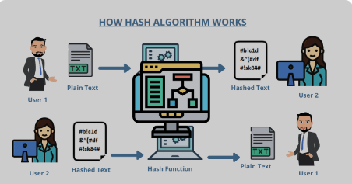

* A hashing algorithm is a mathematical function that takes an input of any size and generates a fixed-size output, known as a hash or message digest.
* The output of a hashing algorithm is unique for each unique input, and it is not possible to determine the input based solely on the output.
* Hashing algorithms are widely used in cryptography and computer security, particularly in the field of digital signatures and data integrity.
* They are used to ensure that data is not tampered with or altered during transmission or storage.
* Hashing algorithms are used in the implementation of various security mechanisms such as password storage, digital certificates, and blockchain technology.
* Examples of commonly used hashing algorithms include SHA-256, MD5, and SHA-3.
* The security and suitability of a hashing algorithm for a particular application depend on several factors, including the length and uniqueness of the hash output, the time and computational resources required to generate the
* Top of Form

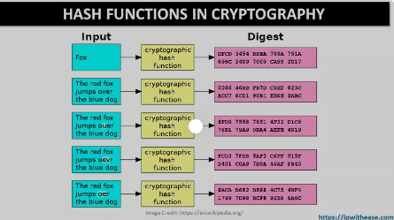

What is encryption

* Encryption is the process of converting plaintext into ciphertext using an algorithm and a key.
* The purpose of encryption is to protect sensitive information from unauthorized access and to ensure confidentiality, integrity, and authenticity of the data.
* Encryption works by using a secret key or a pair of public and private keys to transform plaintext data into ciphertext.
* The ciphertext can only be read by someone who has the corresponding secret key or private key to decrypt the data.
* Encryption can be performed using symmetric-key cryptography, where the same key is used for both encryption and decryption, or using public-key cryptography, where a pair of keys is used to encrypt and decrypt data.
* Encryption is widely used in various applications, such as securing online transactions, protecting sensitive data, and ensuring the privacy of communications.
* Some common examples of encryption in use include TLS/SSL, file and disk encryption, email encryption, and password encryption.
* While encryption can provide a high level of security, it is not foolproof, and there are various attacks that can be used to break encryption.
* Therefore, it is important to use strong encryption algorithms and keys and to follow best practices for key management and encryption implementation to ensure the highest level of security.
* Top of Form

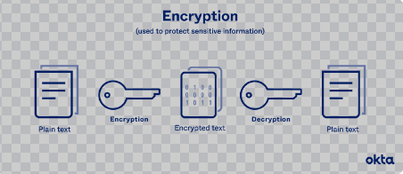

What is decryption-

* Decryption is the process of converting ciphertext (encoded, unreadable data) back into plaintext (plain, readable data) using an algorithm and a key.
* The purpose of decryption is to recover the original plaintext data from its encoded form.
* Decryption involves using the same secret key or private key that was used for encryption to transform the ciphertext back into plaintext.
* In symmetric-key cryptography, the same key is used for both encryption and decryption, while in public-key cryptography, the private key is used for decryption and the public key is used for encryption.
* Decryption is a critical component of many cryptographic systems, as it is necessary to access encrypted data.
* Without decryption, encrypted data remains unreadable and inaccessible.
* Decryption is subject to various attacks and vulnerabilities, such as brute-force attacks and side-channel attacks.
* Decryption is widely used in various applications, such as secure communication, digital signatures, and password management.
* To ensure the highest level of security when performing decryption, it is important to use strong encryption algorithms and keys, follow best practices for key management, and implement appropriate security measures to prevent attacks and protect sensitive data.
* Top of Form



What is cryptography-

The process of encrypting and decrypting is known as cryptography

What is algorithm-

1. An algorithm is a set of rules and procedures used by nodes in a blockchain network to validate and verify transactions.
2. Algorithms are designed to ensure that the transactions on the blockchain are secure, transparent, and immutable.
3. The most common algorithm used in blockchain technology is the Proof of Work (PoW) algorithm, used by cryptocurrencies like Bitcoin.
4. In the PoW algorithm, nodes compete to solve complex mathematical problems to validate transactions and create new blocks on the Blockchain.
5. Other algorithms used in Blockchain technology include Proof of Stake (PoS), Delegated Proof of Stake (DPoS), and Proof of Authority (PoA).
6. PoS, DPoS, and PoA algorithms vary in their approach to validating transactions and maintaining the integrity of the blockchain.
7. Algorithms are a critical component of blockchain technology, ensuring the security and reliability of blockchain networks.

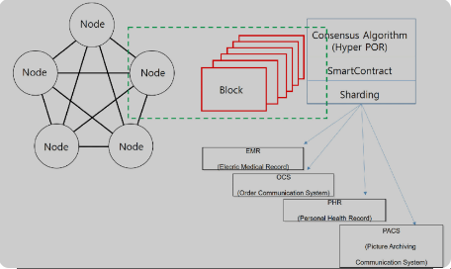Top of Form

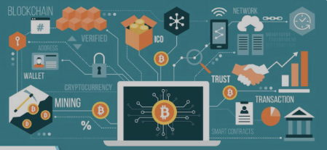

**Merkle Tree**

In this class we are going to study about merkle tree

A Merkle tree is a data structure used in blockchain technology to efficiently verify the integrity and validity of large sets of data. It is named after its inventor, Ralph Merkle.

Merkle Tree in Blockchain-

* A Merkle tree is a data structure that is used to verify the integrity of large sets of data in Blockchain technology.
* It is named after its inventor, Ralph Merkle.
* Data is organized into blocks, and each block is hashed.
* The resulting hash is combined with the hash of another block to create a new hash, and this process continues until all the blocks are combined into a single hash, known as the Merkle root.
* The Merkle root is included in the blockchain, along with other transaction data.
* To verify the integrity of a specific transaction, a user can request the Merkle root from the blockchain and use it to follow a path from the Merkle root to the specific transaction.
* Intermediate hashes along the way are used to verify that each block is valid.
* Using a Merkle tree allows for efficient verification of large sets of data, since users can check the Merkle root to verify the entire set at once.
* The Merkle root is also useful for detecting any tampering with the data, since any changes to the data would result in a different Merkle root.
* Merkle trees are widely used in blockchain technology, including in Bitcoin and Ethereum.

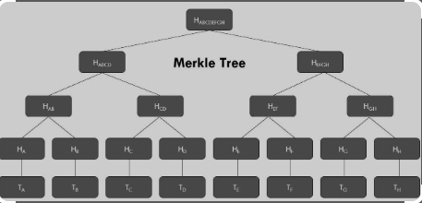Top of Form

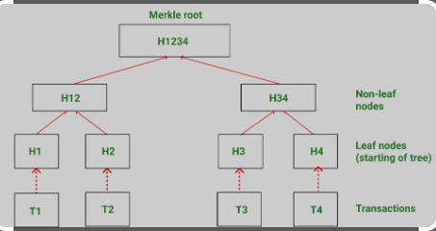

**Shared immutable Distributed ledger**

* An immutable distributed ledger is a type of database that is decentralized and stores transactions in a permanent, unalterable way.
* In an immutable distributed ledger, each node has a copy of the database and validates transactions, making it difficult for any one party to manipulate or alter the data.
* Once a transaction is recorded in the ledger, it cannot be modified or deleted.
* This creates a high level of transparency and trust, since all parties involved can view the same information and have confidence that it is accurate and unaltered.
* Immutable distributed ledgers are used in various industries, such as finance, healthcare, and supply chain management.
* One of the most well-known implementations of an immutable distributed ledger is the blockchain technology used in cryptocurrencies like Bitcoin and Ethereum.

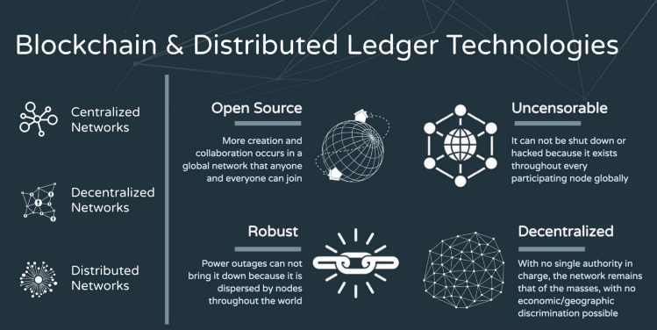

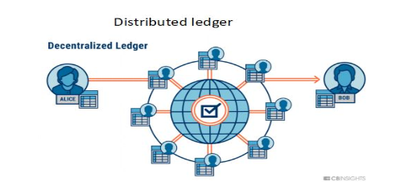

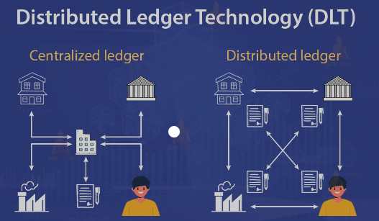

What is pair to pair network

* A peer-to-peer network is a type of decentralized network where computers (known as nodes) communicate and share resources directly with each other, without the need for a central server or authority.
* In a peer-to-peer network, each node acts as both a client and a server, and can send and receive data from other nodes.
* P2P networks can be used for a variety of applications, such as file sharing, messaging, and content delivery.
* One of the key advantages of P2P networks is their ability to scale easily and handle large amounts of data, since the workload is distributed across multiple nodes.
* Another advantage of P2P networks is their resilience, since there is no single point of failure that can bring down the entire network.
* However, P2P networks can also be vulnerable to security and privacy issues, since there is no central authority to manage access control or enforce security policies.
* Different types of P2P networks include structured (such as distributed hash tables) and unstructured networks (such as Gnutella).
* Examples of popular P2P applications include Bit Torrent for file sharing, Skype for messaging and VoIP, and Blockchain technology for decentralized record-keeping.
* P2P networks have been the subject of legal and regulatory scrutiny, particularly in relation to copyright infringement and piracy, due to their potential use for sharing copyrighted content without permission.
* Top of Form

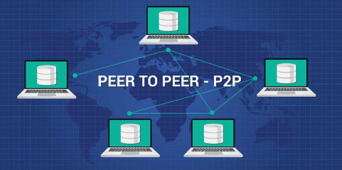

Type of pair to pair network-

Unstructured pair to pair network-

Unstructured peer-to-peer networks do not impose a particular structure on the overlay network by design, but rather are formed by nodes that randomly form connections to each other. (Gnutella, Gossip, and Kazaa are examples of unstructured P2P protocols).

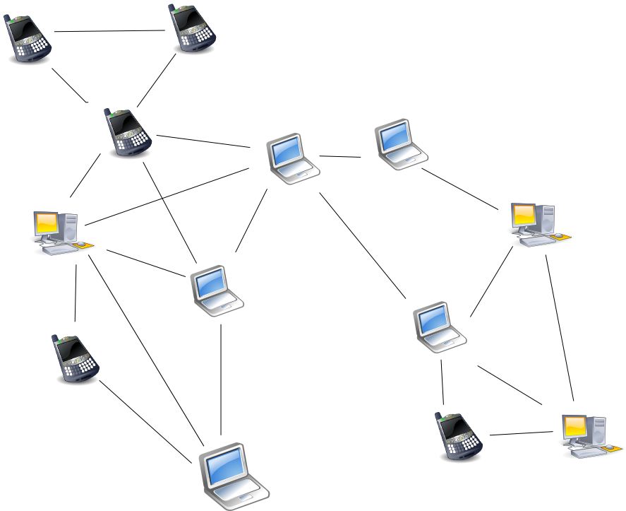

structured pair to pair network-

Structured peer-to-peer (P2P) networks are the opposite of unstructured P2P networks in that the nodes have a way to interact with each other in a more organized manner. This is achieved through a well-organized architecture that allows users to find and use files more efficiently rather than searching randomly.

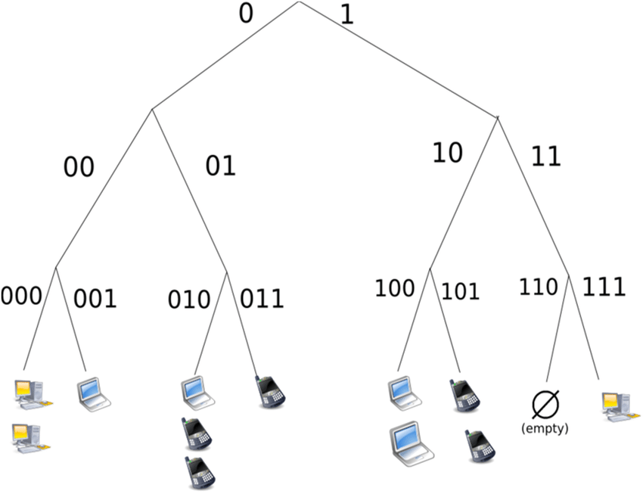

hybrid pair to pair network-

Hybrid peer-to-peer (P2P) networks combine the peer-to-peer architecture with the client-server model. This allows for a central server with P2P capabilities, which can be beneficial for certain types of networks.

Adbaa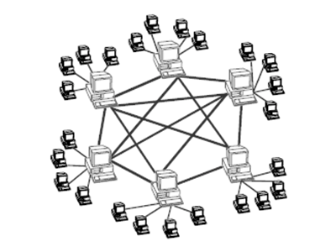

Advantages of p2p network-

* Easy to maintenance-

Each computer in the peer to peer network manages itself. So, the network is quite easy to set up and maintain. In the client server network, the server handles all the requests of the clients.21-Jun-2020

* Lower cost-

Due to the fact that there is no central server in a peer-to-peer network, each peer is responsible for storing and sending the requested information. There are no fees charged by the server that is hosting the application. High security – A peer-to-peer network has no single point of failure

* No network manager-

Some advantages of P2P networks are the following: P2P networks operate without an expensive server. Each user manages their own computer, eliminating the need for a network manager. P2P network configuration occurs via wizards in software.

* Adding nodes is easy-

adding, removing and repairing node is easy in this network.

* Less network traffic-

In p2p network there is less network traffic in client side and server side

Disadvantages of p2p network-

* Data vulnerability-

Since there is no central server data is always prone to loos due to no backup

* Less secure-

Since each node is independent it is default to secure the entire network

* Poor performance-

In p2p network each computer is accused by other computers in the network which slow down the user’s performances

* Difficult to locate files-

In p2p network files are not stored centrally but on separate computer, which makes difficult to locate the file

How does p2p network works-

* Decentralized architecture: A P2P network is a decentralized architecture that does not rely on a central server or authority to manage communication between nodes. Instead, each node in the network is responsible for its own actions.
* Nodes: In a P2P network, each node is connected to other nodes in the network, forming a mesh of connections. Nodes can join or leave the network at any time without affecting the overall functionality of the network.
* Resource sharing: One of the primary functions of a P2P network is resource sharing. Nodes can share files, data, and other resources with other nodes in the network without relying on a central server.
* Peer discovery: In order to share resources, nodes in a P2P network need to discover each other. This can be done through various methods, such as using a centralized directory or using a distributed hash table (DHT) to locate peers.
* Communication protocols: P2P networks use various communication protocols to facilitate communication between nodes, such as Bit Torrent, Gnutella, and Napster.
* Security: P2P networks can be vulnerable to security threats such as malware, viruses, and hacking. To mitigate these threats, P2P networks can use various security measures such as encryption and digital signatures.

Application of pair to pair network-

* File sharing: P2P networks are commonly used for file sharing. Each user in the network can share files with others, and each user can also download files from other users. Examples of P2P file sharing networks include BitTorrent and eMule.
* Content distribution: P2P networks can also be used for content distribution, where a large file or a piece of content is distributed across multiple nodes in the network. This approach can help to reduce the load on centralized servers and improve the overall speed and efficiency of content delivery. Examples of P2P content distribution networks include the InterPlanetary File System (IPFS) and the Ethereum blockchain.
* Messaging and chat: P2P networks can be used for messaging and chat applications where users can communicate with each other directly, without the need for a centralized server. This approach can help to improve privacy and security, as well as reduce the risk of censorship or surveillance. Examples of P2P messaging and chat applications include Tox and Ricochet.
* Online gaming: P2P networks can be used for online gaming, where players can connect directly with each other to play games without the need for a centralized server. This approach can help to reduce lag and improve the overall gaming experience. Examples of P2P online gaming networks include the Blizzard Entertainment Battle.net and the Steam network.
* Distributed computing: P2P networks can also be used for distributed computing, where multiple nodes in the network work together to solve a complex computational problem. This approach can help to improve the speed and efficiency of scientific research, data analysis, and other computational tasks. Examples of P2P distributed computing networks include the Berkeley Open Infrastructure for Network Computing (BOINC) and the Folding@home project.

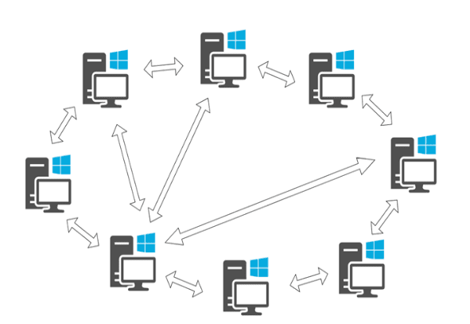

* Top of Form

**Overview of Blockchain technology-**

Blockchain technology is a decentralized and distributed digital ledger that records transactions in a secure and transparent manner. It was initially developed as the underlying technology for cryptocurrencies, such as Bitcoin, but its potential applications have since expanded to many other industries.

At its core, a Blockchain is a chain of blocks, where each block contains a record of several transactions. These blocks are cryptographically linked, creating an immutable and tamper-proof chain of data. This means that once a block is added to the chain, it cannot be modified without also modifying all subsequent blocks, which is computationally infeasible and thus highly secure.

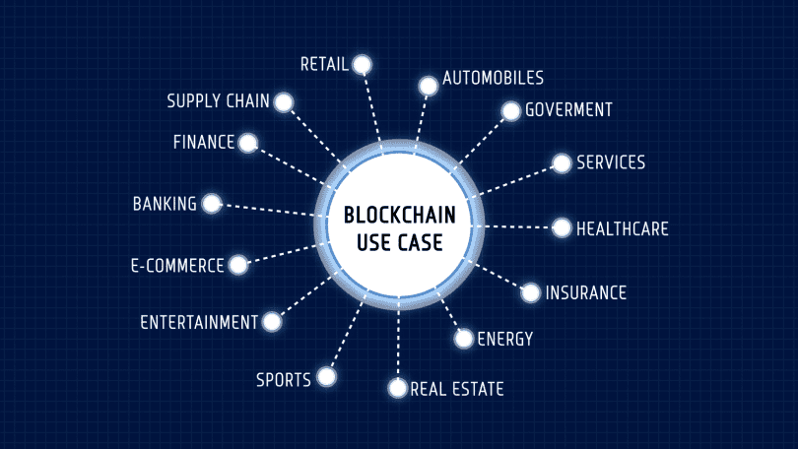

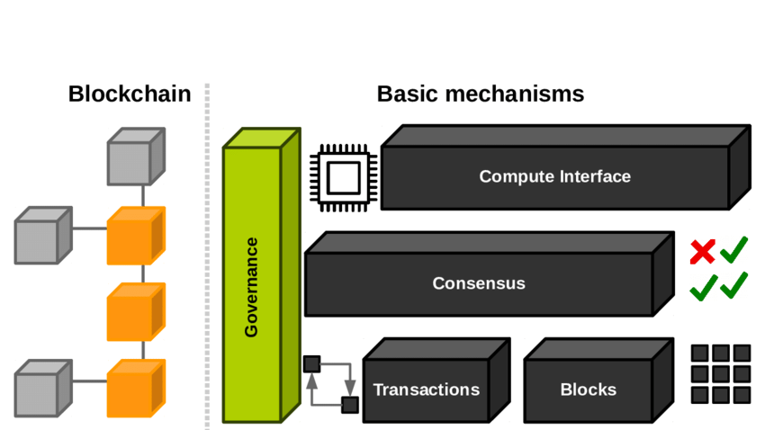

Introduction of cryptocurrency

* Cryptocurrency is a digital or virtual currency that uses encryption techniques to secure and verify transactions.
* Cryptocurrencies are decentralized, meaning they are not controlled by a single authority such as a central bank.
* The first and most well-known cryptocurrency is Bitcoin, created in 2009 by an unknown person or group using the pseudonym Satoshi Nakamoto.
* Cryptocurrencies operate on a distributed ledger technology called blockchain, which is a public ledger of all cryptocurrency transactions.



* Cryptocurrencies offer faster and cheaper transactions, enhanced privacy and security, and a decentralized and transparent system.
* Cryptocurrencies are not backed by any physical asset or government, and their value is determined by market demand and supply.
* Despite their benefits, cryptocurrencies are associated with risks such as high volatility, potential for fraud and hacking, and lack of regulation.
* Other popular cryptocurrencies include Ethereum, Litecoin, and Ripple.
* Cryptocurrencies are increasingly used for online transactions, investments, and as a store of value.
* Cryptocurrencies are rapidly evolving as a new form of digital asset, and their impact on the future of finance is still being studied and debated.
* Top of Form
* Regen
* Bottom of Form



How to create your own cryptocurrency?

Creating your own cryptocurrency requires a significant amount of technical knowledge and expertise. Here are some general steps that you could follow:

* Determine the purpose and functionality of your cryptocurrency. Consider its intended use, target market, and unique features that differentiate it from other cryptocurrencies.
* Decide on the type of Blockchain that will underpin your cryptocurrency. You can either create your own Blockchain or use an existing one.
* Choose a consensus mechanism, which determines how transactions are validated on the Blockchain. Popular consensus mechanisms include Proof of Work (PoW), Proof of Stake (PoS), and Delegated Proof of Stake (DPoS).
* Define the parameters of your cryptocurrency, such as the maximum supply, block size, block time, and transaction fees.
* Develop the code for your cryptocurrency using a programming language such as C++, Python, or Solidity.
* Test your cryptocurrency on a testnet to identify and resolve any bugs or issues.
* Launch your cryptocurrency by making it available for public use and trading on cryptocurrency exchanges.
* Market and promote your cryptocurrency to attract users and investors.
* It's important to note that creating your own cryptocurrency is a complex process and requires a deep understanding of Blockchain technology and cryptography. Additionally, the success of a cryptocurrency depends on various factors such as its utility, adoption rate, and market demand, among others. Therefore, it's essential to do thorough research and seek expert advice before embarking on such a project.
* Top of Form

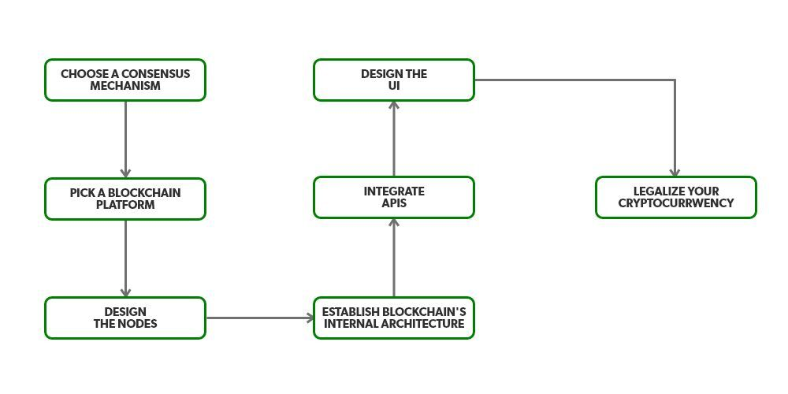

Type of network-

There are four main types of Blockchain networks: public Blockchain, private Blockchain, consortium Blockchain and hybrid Blockchain. A [Blockchain network](https://www.analyticssteps.com/blogs/3-types-block-blockchain-network) is basically a technical network that is providing ledger and smart contract (chain code) services to the applications. Primarily, these smart contracts are used to generate transactions which are subsequently distributed among every peer node in the network where they are unalterably recorded on their copy of the ledger. The users of applications must be end users using client applications.

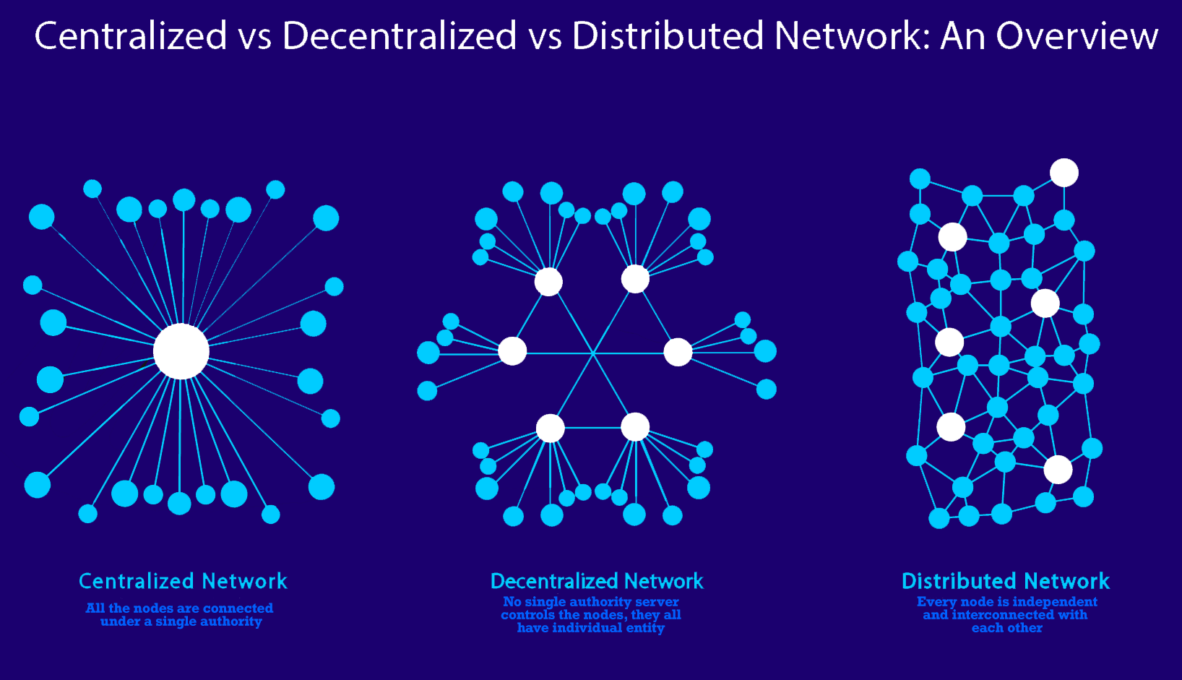

Peer- to- peer network-

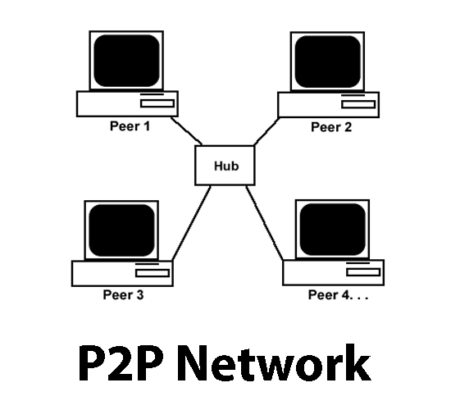

A peer-to-peer (**P2P**) **network** is a communications model in which each computing device on the network can function as either a server or a client.

Distributed peer to peer network

A distributed peer-to-peer network (also known as P2P network) is a type of computer network where each participant (or node) in the network has equal abilities and responsibilities in sharing resources and processing data. In a P2P network, there is no central server or authority controlling the network; instead, each node can directly communicate with other nodes in the network.

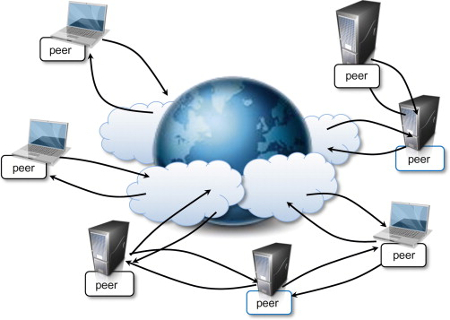

Blockchain vs cryptocurrency

Blockchain, being a public ledger, is highly transparent. Anyone can join a blockchain network and view the information available. On the other hand, cryptocurrencies offer anonymity. So, while anyone can see the source/destination of a bitcoin transaction, no one can know who is behind the transaction.

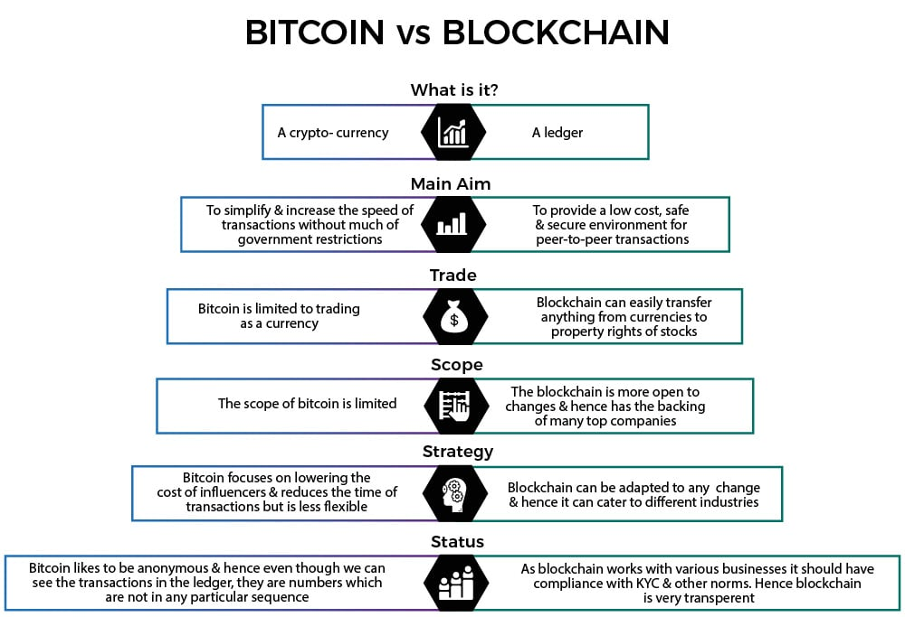

**Fungible and non-fungible token-**

Fungible tokens or assets are divisible and non-unique. For instance, fiat currencies like the dollar are fungible: A $1 bill in New York City has the same value as a $1 bill in Miami. A fungible token can also be a cryptocurrency like Bitcoin: 1 B

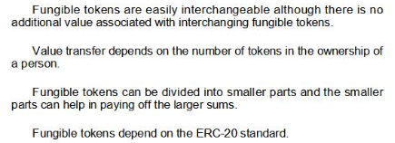

TC is worth 1 BTC, no matter where it is issued.

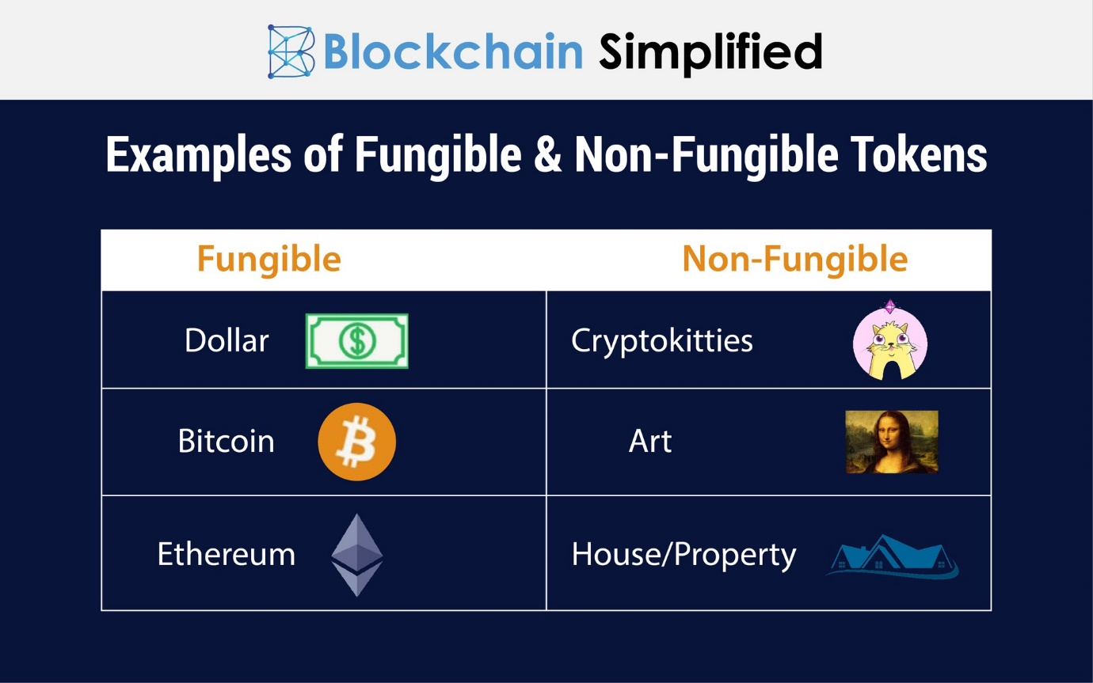

Non-fungible token-

Non-fungible tokens, often referred to as NFTs, are blockchain-based tokens that each represent a unique asset like a piece of art, digital content, or media. An NFT can be thought of as an irrevocable digital certificate of ownership and authenticity for a given asset, whether digital or physical.

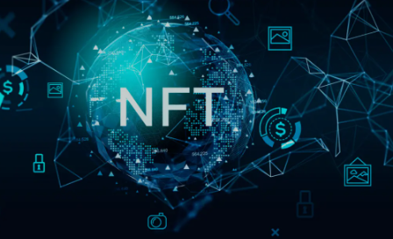

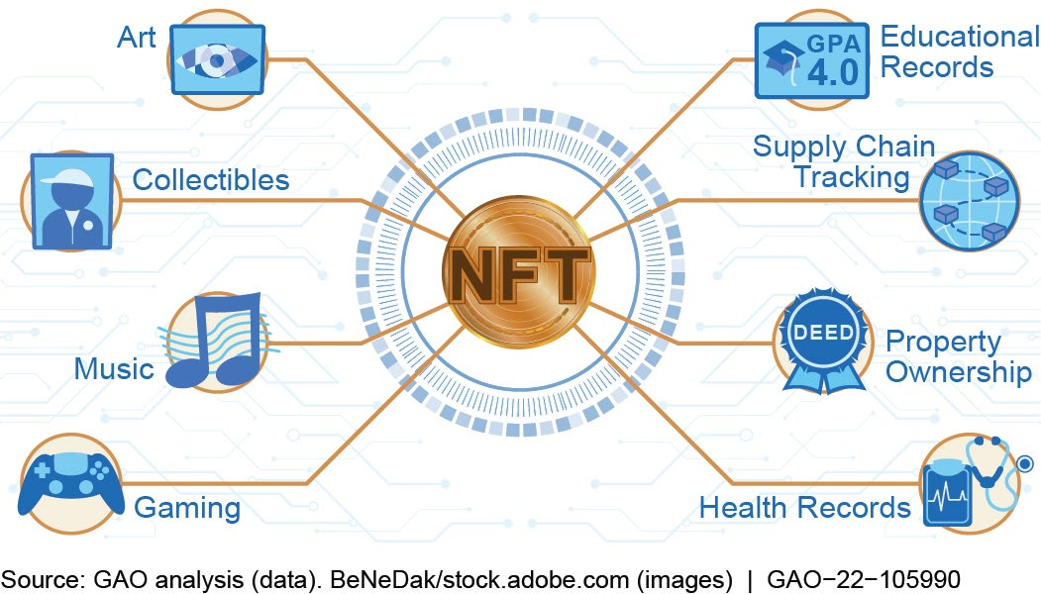

**Introduction of DApp**

A decentralized application (dapp) is an application built on a decentralized network that combines a smart contract and a frontend user interface. On Ethereum, smart contracts are accessible and transparent – like open APIs – so your dapp can even include a smart contract that someone else has written.

What is public blockchain-

* A public blockchain is a decentralized, distributed ledger technology that is open to anyone.
* Transactions on a public blockchain are recorded and validated by a network of nodes, rather than a single centralized entity.
* Public blockchains are transparent, with all transactions visible to anyone on the network.
* Transactions on a public blockchain are secured through cryptography and a consensus mechanism.
* Public blockchains are immutable, meaning that once a transaction is recorded on the blockchain, it cannot be changed or deleted.
* Public blockchains are permission less, meaning that anyone can participate in the network and create decentralized applications (dApps).
* Public blockchains are often used for cryptocurrencies, but can also be used for other applications, such as supply chain tracking, voting systems, and more.

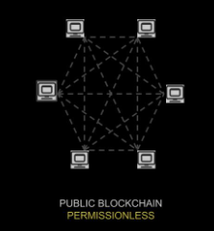

What is private blockchain-

* A private blockchain is a decentralized, distributed ledger technology that is restricted to a specific group of participants.
* Transactions on a private blockchain are recorded and validated by a network of nodes that are known and trusted by the participants.
* Private blockchains are more secure than public blockchains, as they have a limited number of participants and can require permission to access the network.
* Private blockchains are not transparent, as transactions are only visible to the participants on the network.
* Private blockchains are often used by organizations for internal purposes, such as supply chain management, record-keeping, and data sharing.
* Private blockchains can be customized to meet the specific needs of the participants, and can be more efficient than public blockchains.
* Private blockchains can also have their own native tokens, which can be used as a means of exchange or to access specific services within the network.
* Top of Form

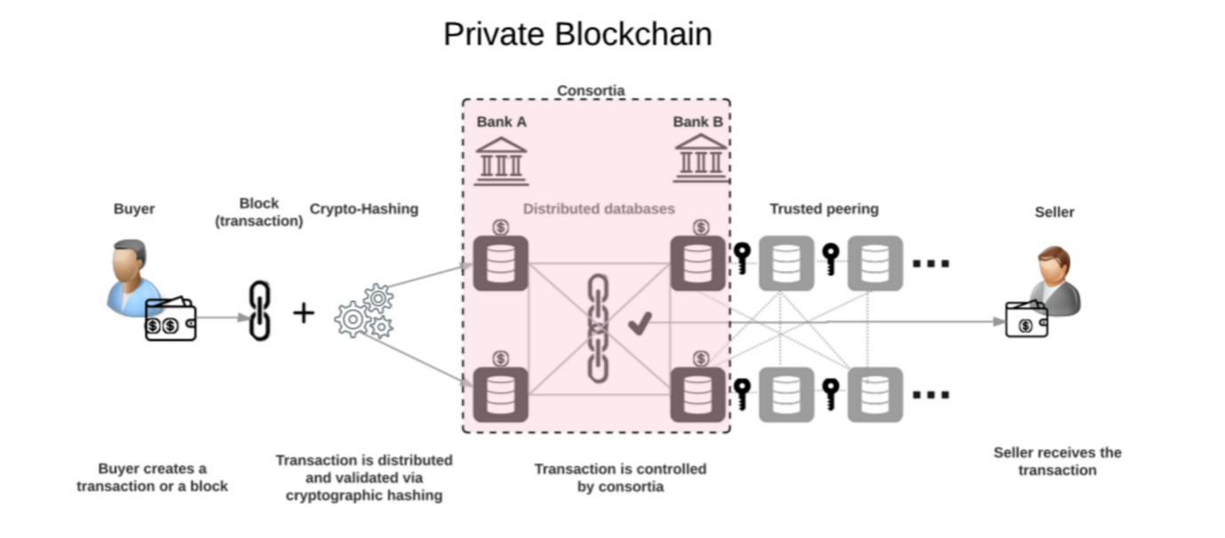

**Federated and consortium blockchain-**

1. A federated blockchain is a hybrid model that combines the features of public and private blockchains.
2. A federated blockchain allows for a group of known and trusted participants to control the network, rather than a single centralized entity.
3. Transactions on a federated blockchain are validated by a smaller set of nodes or validators, which can improve transaction speed and scalability.
4. Federated blockchains are more efficient than public blockchains, but less secure than private blockchains.

Consortium Blockchain:

1. A consortium blockchain is a private blockchain that is controlled by a group of organizations rather than a single entity.
2. A consortium blockchain is used to create a decentralized network that can be accessed and used by multiple organizations, while maintaining a high level of security.
3. Transactions on a consortium blockchain are recorded and validated by the network participants, which can reduce transaction fees and improve efficiency.
4. Consortium blockchains can be used for supply chain management, financial services, and other applications where multiple organizations need to share data and collaborate on a secure platform.

Top of Form

How to create NFT on Ethereum blockchain-

* Choose a platform or marketplace: There are several platforms and marketplaces that allow you to create and sell NFTs on the Ethereum blockchain, such as OpenSea, Rarible, and SuperRare.
* Connect to a wallet: You will need to connect your Ethereum wallet to the NFT platform or marketplace to create and sell your NFT. MetaMask is a popular wallet that you can use to connect to these platforms.
* Create your NFT: Once you are connected to the platform or marketplace, you can start creating your NFT. This typically involves uploading a digital file, such as an image or video, and adding metadata to describe the NFT.
* Mint your NFT: To mint your NFT, you will need to pay a fee in Ethereum to cover the cost of creating the NFT and adding it to the blockchain. This fee is typically referred to as a gas fee.
* List your NFT for sale: Once your NFT is minted, you can list it for sale on the platform or marketplace. You can set a price in Ethereum or choose to auction off your NFT.
* Transfer your NFT: Once your NFT is sold, you can transfer ownership to the buyer by sending it to their Ethereum wallet. This typically involves paying another gas fee.

Note that the exact steps may vary depending on the platform or marketplace you choose, and the process can involve some technical knowledge of Ethereum and blockchain technology.

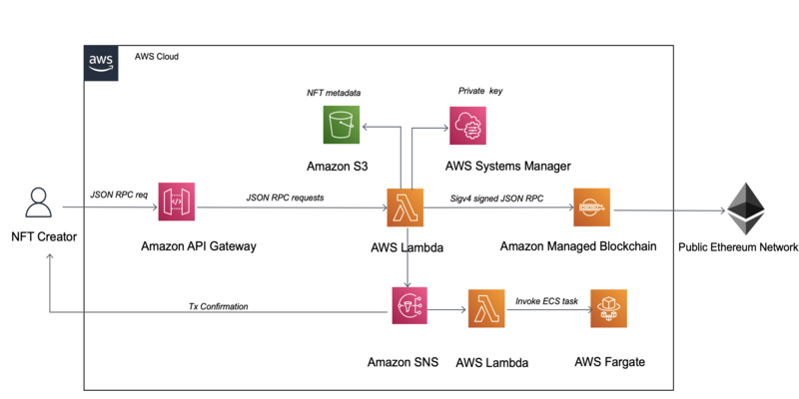

How to create NFT on polygon Blockchain-

* Choose a wallet: You will need to have a Polygon-compatible wallet that supports the creation and management of NFTs. Some popular wallets include MetaMask, WalletConnect, and Fortmatic.
* Choose a platform: There are several platforms that allow you to create and mint NFTs on the Polygon network, such as OpenSea, Mintable, and Rarible. Choose the one that best fits your needs.
* Create your NFT: Once you have chosen a platform, you can start creating your NFT. This involves designing the artwork, deciding on the properties, and creating a unique metadata file that describes your NFT.
* Mint your NFT: After you have created your NFT, you will need to mint it on the Polygon blockchain. This involves paying a gas fee and following the platform's instructions to complete the process.
* List your NFT for sale: Once your NFT is minted, you can list it for sale on the platform where you created it. You can set the price and choose whether to auction it or sell it for a fixed price.
* Transfer your NFT: If you want to transfer your NFT to another wallet or sell it on a different platform, you can use the transfer function to send it to the new owner.

Note that the specific steps may vary slightly depending on the platform you choose and the type of NFT you are creating. Make sure to do your research and follow the instructions carefully to ensure a smooth process.

HH

* Top of Form

How to sell NFT on Ethereum Blockchain-

* Choose a marketplace: There are several popular marketplaces for NFTs on the Ethereum network, such as OpenSea, Rarible, and SuperRare. Choose the marketplace that best fits your needs.
* Create an account: You will need to create an account on the marketplace you have chosen. This will typically involve connecting your Ethereum wallet, such as MetaMask, to the marketplace.
* List your NFT: Once you have an account, you can list your NFT for sale. This involves creating a listing that includes the price, description, and any other relevant information about your NFT. You will also need to pay a listing fee, which varies depending on the marketplace.
* Wait for a buyer: Once your NFT is listed, you will need to wait for a buyer to purchase it. You can also promote your NFT on social media or other platforms to increase visibility and attract potential buyers.
* Transfer your NFT: Once a buyer has purchased your NFT, you will need to transfer it to their Ethereum wallet. This typically involves a simple transfer function on the marketplace you used to sell the NFT.
* Receive payment: After you have transferred the NFT, you should receive payment in the form of cryptocurrency, which will be deposited in your Ethereum wallet.

Note that the specific steps may vary slightly depending on the marketplace you choose and the type of NFT you are selling. Make sure to do your research and follow the instructions carefully to ensure a smooth process.

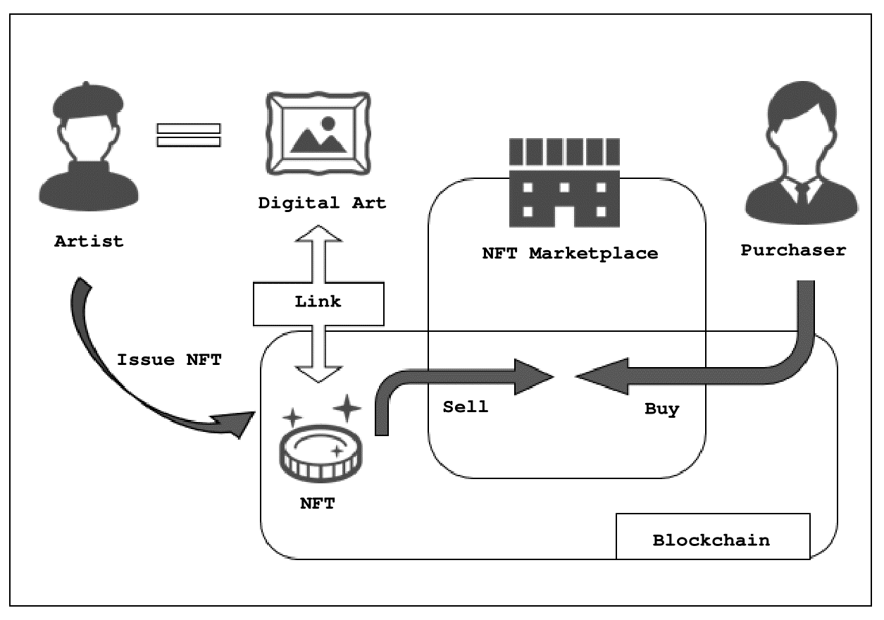Top of Form

How to sell NFT on polygon Blockchain-

* Choose a marketplace: There are several marketplaces for NFTs on the Polygon network, such as OpenSea and Mintable. Choose the marketplace that best fits your needs.
* Create an account: You will need to create an account on the marketplace you have chosen. This will typically involve connecting your Polygon-compatible wallet, such as MetaMask, to the marketplace.
* List your NFT: Once you have an account, you can list your NFT for sale. This involves creating a listing that includes the price, description, and any other relevant information about your NFT. You will also need to pay a listing fee, which varies depending on the marketplace.
* Wait for a buyer: Once your NFT is listed, you will need to wait for a buyer to purchase it. You can also promote your NFT on social media or other platforms to increase visibility and attract potential buyers.
* Transfer your NFT: Once a buyer has purchased your NFT, you will need to transfer it to their Polygon wallet. This typically involves a simple transfer function on the marketplace you used to sell the NFT.
* Receive payment: After you have transferred the NFT, you should receive payment in the form of cryptocurrency, which will be deposited in your Polygon wallet.
* Note that the specific steps may vary slightly depending on the marketplace you choose and the type of NFT you are selling. Make sure to do your research and follow the instructions carefully to ensure a smooth process.
* Top of Form

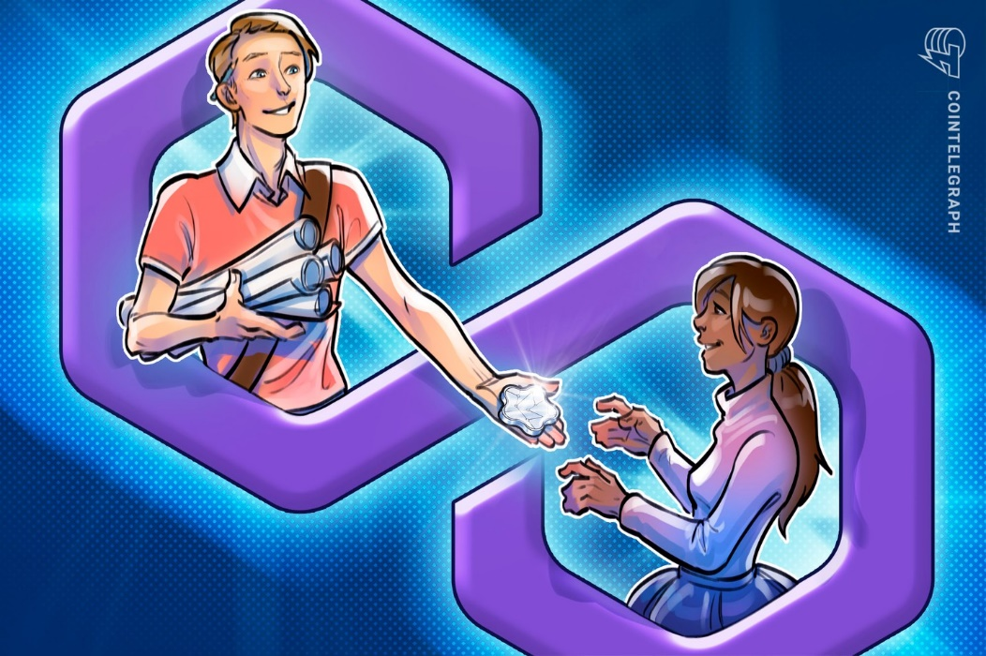

* Top of Form

Difference between cryptocurrency token and non-fungible token-

Cryptocurrency Token:

* A digital asset designed to function as a medium of exchange, similar to traditional currency
* Fungible, meaning each unit of the token is interchangeable and has the same value as any other unit of the same token
* Used for transactions and as a store of value
* Examples include Bitcoin, Ethereum, and Binance Coin

Non-Fungible Token (NFT):

* A unique digital asset that represents ownership of a particular item or piece of content
* Non-fungible, meaning each NFT is unique and has a specific value
* Used in the context of digital art and collectibles, where each NFT represents a one-of-a-kind piece that cannot be replicated or duplicated
* Examples include CryptoKitties, NBA Top Shot, and digital art sold on platforms such as OpenSea and SuperRare

In summary, cryptocurrency tokens are fungible digital assets designed for use as a medium of exchange, while NFTs are unique digital assets used to represent ownership of a specific item or piece of content.

Fungible vs non-fungible tokenTop of Form

Fungible:

* Interchangeable with other units of the same type
* Every unit has the same value as any other unit of the same type
* Examples include traditional currency, cryptocurrencies, and commodity futures contracts

Non-Fungible:

* Unique and not interchangeable with other units of the same type
* Each unit has a distinct value
* Examples include collectibles, real estate, and digital assets such as NFTs

In summary, fungible items are interchangeable with other units of the same type and have the same value, while non-fungible items are unique and have a distinct value.

Top of Form

Regenerate response

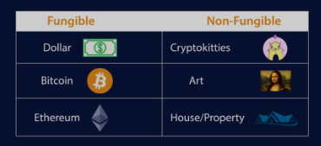

**Why cryptocurrency were instant hit**

* Decentralization: Cryptocurrencies operate independently of central banks and government control. This means that users have more control over their own funds, and can make transactions without intermediaries such as banks.
* Security: Transactions in cryptocurrencies are secured through advanced encryption techniques, which make them more secure than traditional payment methods. Transactions are also recorded on a decentralized public ledger, making it difficult to alter or falsify records.
* Anonymity: Cryptocurrencies offer a higher level of anonymity compared to traditional payment methods. Users can make transactions without revealing their personal information, making it a preferred method for people who value privacy.
* Global acceptance: Cryptocurrencies can be used for transactions worldwide without the need for currency exchange. This makes them a popular choice for international transactions.
* Investment opportunity: Many people also view cryptocurrencies as a potential investment opportunity due to their volatile nature and the potential for high returns.
* Overall, cryptocurrencies have gained popularity due to their unique features and advantages over traditional currencies, leading to a surge in demand and an instant hit. However, it is important to note that cryptocurrencies are still a relatively new technology, and there are risks associated with investing in them.
* Top of Form



**Feature to define Blockchain-**

* Decentralization: Blockchain is a decentralized technology, meaning it is not controlled by a single entity or organization. Instead, it is distributed across a network of nodes that verify and record transactions.
* Immutable: Once data is recorded on a blockchain, it cannot be altered or deleted. This makes blockchain a secure and tamper-proof ledger.
* Cryptography: Blockchain uses advanced cryptographic techniques to ensure that transactions and data on the network are secure and private.
* Consensus: In order for a transaction to be recorded on a blockchain, a consensus must be reached among the nodes on the network. This consensus mechanism ensures the integrity of the network and prevents double-spending.
* Smart Contracts: Blockchain technology allows for the creation of smart contracts, which are self-executing contracts with the terms of the agreement between buyer and seller being directly written into lines of code.
* Transparency: The transaction history on a blockchain is transparent and publicly visible, meaning anyone can view the transactions that have occurred on the network.
* Trustless: Blockchain eliminates the need for trust between parties, as transactions are verified and recorded by the network as a whole rather than relying on trust in a central authority.
* Top of Form

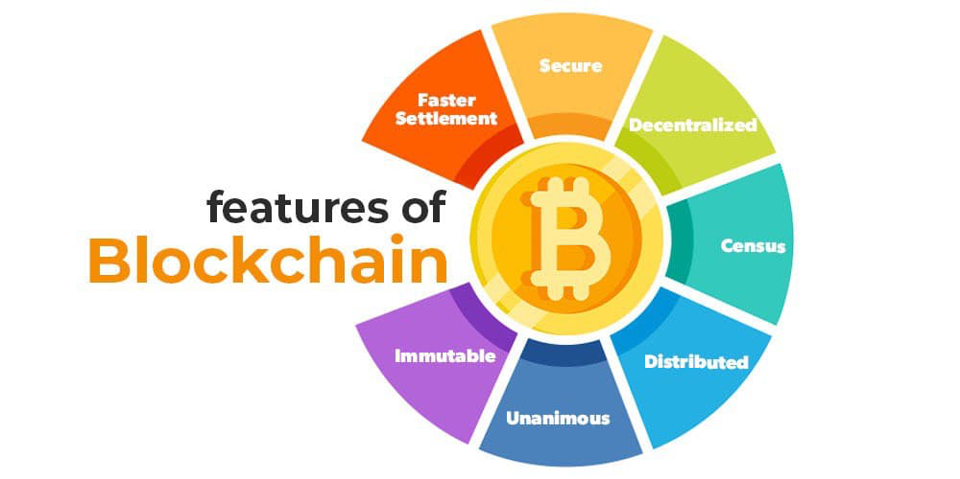

Why Blockchain-

* Security: Blockchain technology uses advanced cryptographic techniques to ensure that transactions and data on the network are secure and tamper-proof. This makes it an ideal solution for industries that require high levels of security, such as finance and healthcare.
* Transparency: The transparent and publicly visible nature of blockchain makes it an ideal solution for industries that require transparency and accountability, such as supply chain management and voting systems.
* Decentralization: Blockchain's decentralized nature eliminates the need for a central authority to verify and record transactions, making it a more democratic and inclusive technology.
* Efficiency: Blockchain technology can automate many processes and eliminate the need for intermediaries, reducing the time and cost of transactions.
* Trustless: The trustless nature of blockchain eliminates the need for trust between parties, making it an ideal solution for industries where trust is difficult to establish, such as international trade.
* Innovation: Blockchain technology is a relatively new and innovative technology, and many industries are exploring its potential to revolutionize their operations and create new business models.
* Globalization: Blockchain technology is a global technology, and it can facilitate cross-border transactions and eliminate the need for currency conversions and other obstacles to international trade.
* Top of Form



What is mining-

* Verification: In blockchain technology, mining refers to the process of verifying transactions and adding them to the blockchain ledger.
* Nodes: The mining process is carried out by nodes, which are computers on the blockchain network that solve complex mathematical problems to verify transactions.
* Rewards: As a reward for their work, nodes receive cryptocurrency tokens or transaction fees for adding new blocks to the blockchain.
* Proof of work: The mining process uses a consensus mechanism called proof of work, which requires nodes to expend computational resources to solve mathematical problems in order to validate transactions.
* Difficulty: The difficulty of the mathematical problems increases over time to ensure a steady rate of new blocks being added to the blockchain.
* Security: Mining is an essential part of the security of the blockchain, as it ensures that only valid transactions are added to the blockchain and prevents malicious actors from tampering with the ledger.
* Energy consumption: Mining is a computationally intensive process that requires a significant amount of energy. As a result, some blockchains are exploring alternative consensus mechanisms that require less energy, such as proof of stake.
* Top of Form

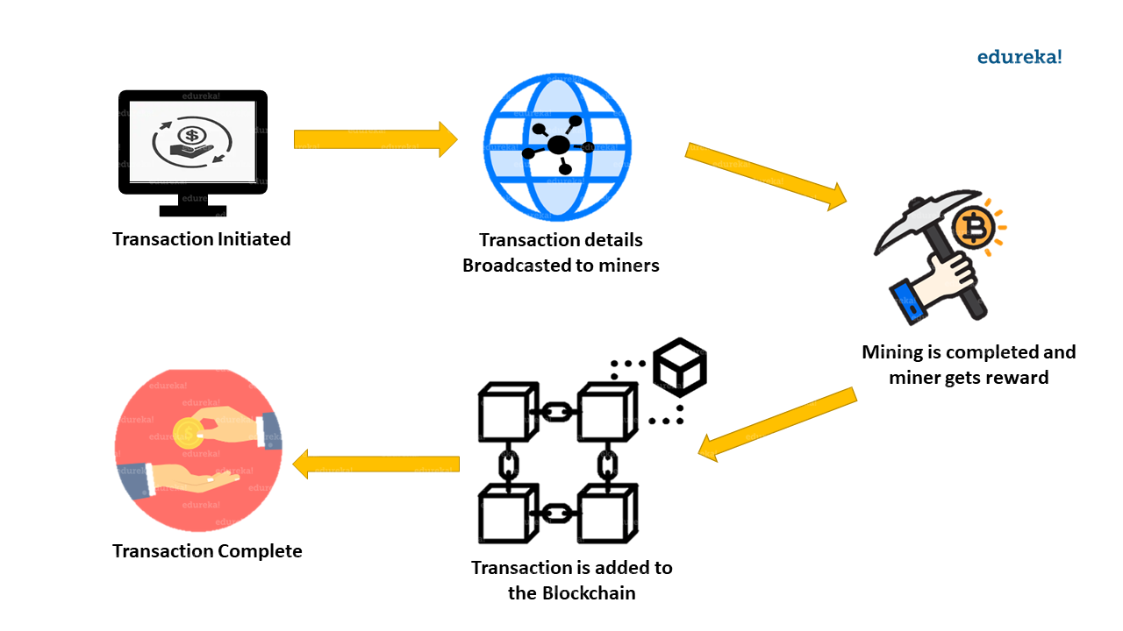

What is proof of work-

Proof of work is a consensus mechanism used in blockchain technology to verify transactions and create new blocks in the blockchain ledger. Here are some key points to understand what proof of work is:

* Verification: Proof of work requires nodes on the blockchain network to solve complex mathematical problems in order to validate transactions and add new blocks to the blockchain.
* Difficulty: The difficulty of the mathematical problems is adjusted over time to ensure a steady rate of new blocks being added to the blockchain.
* Energy consumption: Proof of work is a computationally intensive process that requires a significant amount of energy. Nodes must compete with each other to solve the problems, which can lead to a high level of energy consumption.
* Rewards: Nodes that successfully solve the mathematical problems are rewarded with cryptocurrency tokens or transaction fees for adding new blocks to the blockchain.
* Security: Proof of work is a key component of the security of the blockchain, as it ensures that only valid transactions are added to the blockchain and prevents malicious actors from tampering with the ledger.
* Consensus: The proof of work consensus mechanism ensures that all nodes on the blockchain network agree on the state of the ledger and the order in which transactions are recorded.

Consensus with proof of work-

The proof of work (PoW) is a common consensus algorithm used by the most popular cryptocurrency networks like Bitcoin and Litecoin. It requires a participant node to prove that the work done and submitted by them qualifies them to receive the right to add new transactions to the blockchain.

* Validation: Proof of work requires nodes on the blockchain network to solve complex mathematical problems to validate transactions and add new blocks to the blockchain.
* Difficulty: The difficulty of the mathematical problems is adjusted over time to ensure a steady rate of new blocks being added to the blockchain. This difficulty level is typically adjusted based on the total amount of computing power on the network.
* Energy consumption: Proof of work is a computationally intensive process that requires a significant amount of energy. Nodes must compete with each other to solve the problems, which can lead to a high level of energy consumption.
* Rewards: Nodes that successfully solve the mathematical problems are rewarded with cryptocurrency tokens or transaction fees for adding new blocks to the blockchain.
* Security: Proof of work is a key component of the security of the blockchain, as it ensures that only valid transactions are added to the blockchain and prevents malicious actors from tampering with the ledger.
* Centralization: Proof of work can lead to centralization of the blockchain network, as nodes with the most computing power are more likely to solve the mathematical problems and add new blocks to the blockchain.
* Alternatives: Due to the high energy consumption required by proof of work, some blockchains are exploring alternative consensus mechanisms, such as proof of stake, which require less energy and are more environmentally friendly.

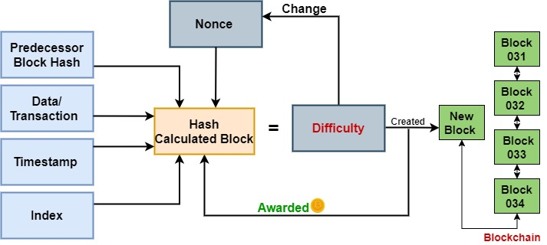

* Top of Form

Usage of public and private keys in Blockchain-

Public-private key cryptography is a key component of Blockchain technology. Here are some key points to understand how public-private keys are used in Blockchain:

1. Security: Public-private key cryptography provides a secure way to authenticate transactions on the Blockchain network. Each user has a unique public-private key pair, and transactions are signed with the private key to ensure their authenticity.
2. Encryption: Public-private key cryptography is used to encrypt sensitive data on the Blockchain network. Data can be encrypted with a user's public key, and can only be decrypted with their corresponding private key.
3. Identity verification: Public-private key cryptography allows users on the Blockchain network to verify each other's identities without the need for a central authority. Users can authenticate each other's public keys, which serves as proof of their identity.
4. Address generation: Public-private key cryptography is used to generate unique addresses for users on the Blockchain network. Each address corresponds to a unique public key, which can be used to send and receive cryptocurrency tokens.
5. Non-repudiation: Public-private key cryptography provides non-repudiation, which means that once a transaction is signed with a private key, it cannot be repudiated or denied by the signer.
6. Key management: Public-private key cryptography requires proper key management to ensure the security of the Blockchain network. Users must keep their private keys secure and not share them with others.
7. Accessibility: Public-private key cryptography makes Blockchain technology accessible to anyone with an internet connection and a device that can generate and manage key pairs. This makes it a more democratic and inclusive technology.

What is crypto-wallet-Top of Form

Crypto **wallets store your private keys, keeping your crypto safe and accessible**. They also allow you to send, receive, and spend cryptocurrencies

Practical’s on usage of public private key in Blockchain

* Digital Signatures: Public-private key cryptography is used to create digital signatures which are used to validate the authenticity and integrity of data stored on the Blockchain. Digital signatures ensure that the data has not been tampered with since it was signed.
* Wallet Addresses: Every user on a Blockchain has a wallet address, which is essentially a public key. This address is used to send and receive cryptocurrency transactions. The private key is used to access the wallet and sign transactions, ensuring that only the owner of the wallet can spend their cryptocurrency.
* Mining Rewards: In some Blockchain networks, miners are rewarded with cryptocurrency for solving cryptographic puzzles. To receive these rewards, miners must prove ownership of a specific wallet address by signing a message with the private key associated with that address.
* Secure Messaging: Public-private key cryptography can be used to secure messaging on a Blockchain. Users can encrypt their messages with the recipient's public key, ensuring that only the recipient can read the message.
* Multi-signature Transactions: Multi-signature transactions require multiple parties to sign off on a transaction before it can be executed. This is achieved through the use of multiple public keys, and the transaction can only be signed with the corresponding private keys.

Overall, public-private key cryptography is essential to the security and functionality of Blockchain networks, enabling users to securely send and receive transactions, validate data, and maintain the integrity of the Blockchain.

* Top of Form

command to be executed on terminal of Linux-

mkdir keys

cd keys

openssl genrsa out private-A 1024

cat Private-A

openssl genrsa-out private-b 1024

cat Private-B

openssl rsa-in private A –out public-A .pub-out form PEM

CAT public-A.pub

Openssl rsa in private-B -out public B.Pub outform PEM

Pubout

Cat public-B.pub

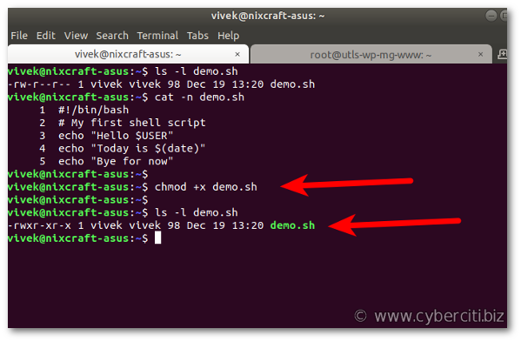

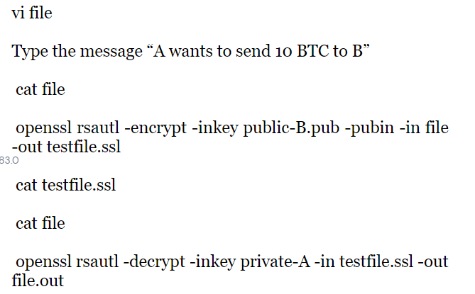

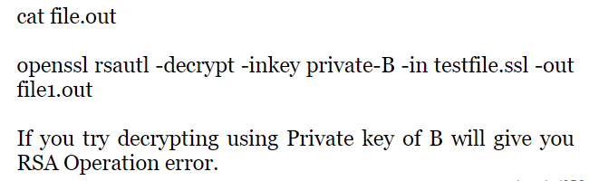

* Top of Form

Threads and challenges of Blockchain

Blockchain technology has gained a lot of attention in recent years due to its potential to revolutionize various industries. However, like any new technology, it comes with its own set of challenges and drawbacks. Here are some of the key challenges and trends in blockchain:

* Scalability: One of the most significant challenges facing blockchain technology is scalability. As more transactions are added to the blockchain, the network can become congested, slowing down transaction times and increasing fees.
* Security: Blockchain technology is often touted as being highly secure, but it is not immune to hacking and cyber attacks. Hackers can exploit vulnerabilities in the system, such as smart contract bugs, to steal funds or disrupt the network.
* Interoperability: As blockchain technology evolves and new blockchains are developed, interoperability between different blockchains becomes a challenge. Currently, there is no standard way for different blockchains to communicate with each other, making it difficult for users to transfer assets from one blockchain to another.
* Regulatory challenges: Blockchain technology is still in its infancy, and regulatory bodies are struggling to keep up with its development. Many countries have yet to establish clear regulations for blockchain-based assets and transactions, creating uncertainty for businesses and investors.
* Energy consumption: The process of validating transactions on a blockchain requires a significant amount of computational power, which in turn consumes a lot of energy. This has led to concerns about the environmental impact of blockchain technology, particularly for blockchains that use proof-of-work consensus algorithms.

Despite these challenges, there are also several promising trends in blockchain technology, including:

* Decentralized finance (DeFi): DeFi refers to a set of financial applications built on top of blockchain technology. These applications aim to provide decentralized, permissionless alternatives to traditional financial services.
* Non-fungible tokens (NFTs): NFTs are digital assets that represent ownership of unique items, such as art, music, or collectibles. They have become popular in recent years as a way for creators to monetize their work and for collectors to invest in rare or one-of-a-kind items.
* Enterprise blockchain adoption: More and more businesses are exploring the use of blockchain technology to improve supply chain management, reduce costs, and increase transparency and security.
* Hybrid blockchains: Hybrid blockchains combine the benefits of both public and private blockchains, allowing businesses to maintain control over their data while still benefiting from the security and transparency of a public blockchain.

Overall, while there are challenges facing blockchain technology, there are also many promising developments that suggest it will continue to play an important role in the future of technology and business.

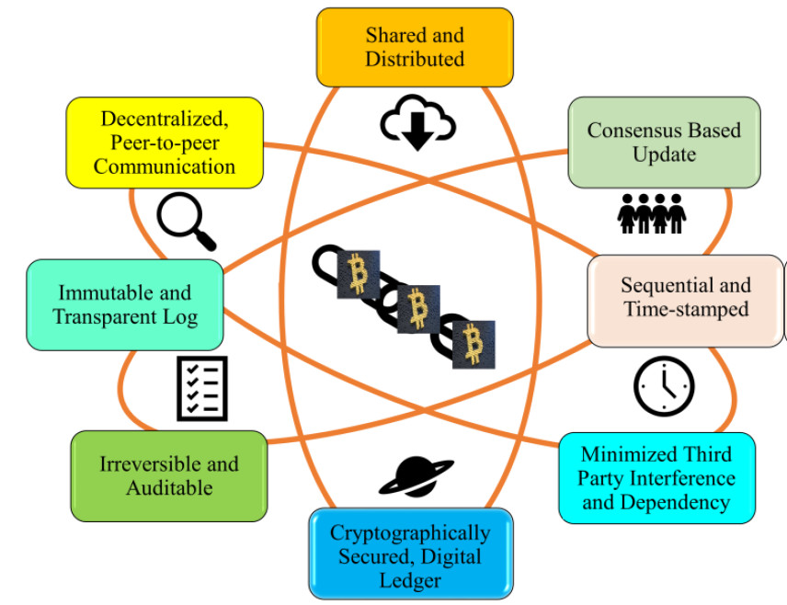Top of Form

What is fork in blockchain-

There are two main types of forks: soft forks and hard forks. A soft fork occurs when a change is made to the blockchain protocol that is backwards compatible with previous versions. This means that nodes running older versions of the software will still recognize the new blocks as valid. In contrast, a hard fork occurs when a change is made to the protocol that is not backwards compatible. This creates a new blockchain that is separate from the original chain, with its own set of rules and history.

Forks can happen for a variety of reasons, including disagreements over the direction of the blockchain or the need to fix a critical bug in the software. When a fork occurs, it can lead to the creation of a new cryptocurrency or the continuation of the existing cryptocurrency on a new chain.

It's worth noting that not all forks are successful or lead to the creation of a new cryptocurrency. Some forks may fail to gain support from the community, while others may simply be used to test new features or improvements to the protocol before they are implemented on the main chain.

Top of Form

Two type of fork-

Hard fork

A hard fork is a type of fork that occurs in a blockchain when a change is made to the protocol that is not backwards compatible with the previous version. This means that nodes running older versions of the software will not recognize the new blocks as valid. As a result, a new chain is created, and the old chain continues to exist separately.

Hard forks can occur for various reasons, such as to fix critical bugs, to implement new features, or due to disagreements within the community. They can also result in the creation of a new cryptocurrency or the continuation of the existing cryptocurrency on a new chain.

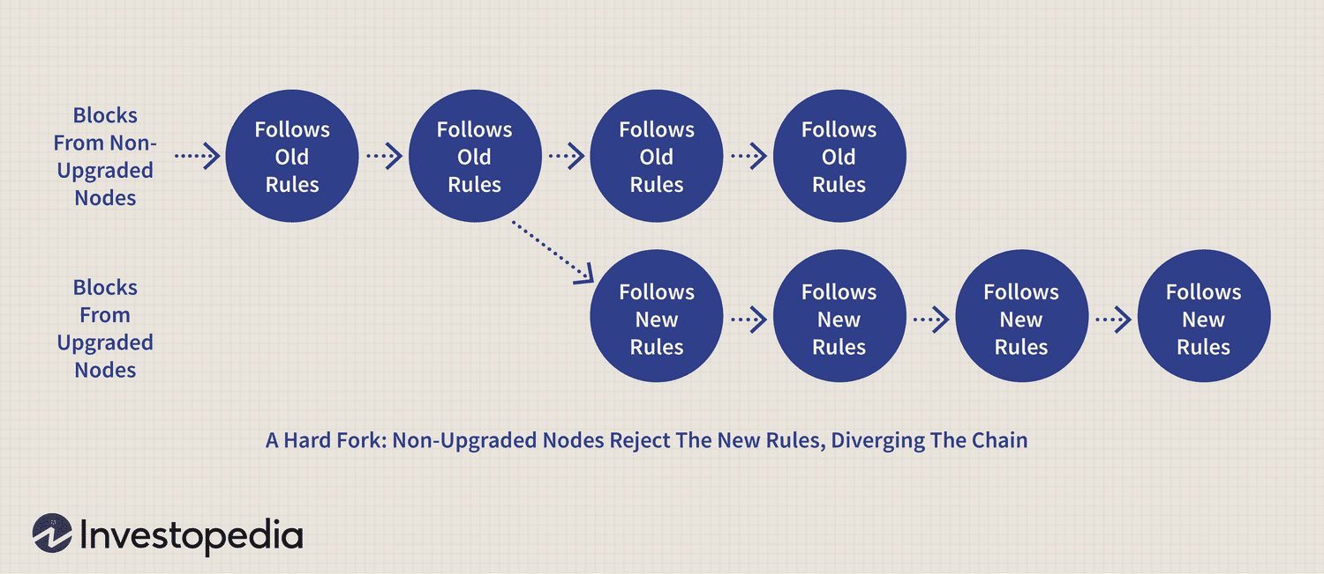

Soft fork-

A soft fork is a type of fork that occurs in a blockchain when a change is made to the protocol that is backwards compatible with the previous version. This means that nodes running older versions of the software will still recognize the new blocks as valid. As a result, the new chain created by the soft fork will remain compatible with the existing chain.

Soft forks are typically used to implement minor changes or updates to the protocol, such as fixing bugs or adding new features. They require fewer nodes to upgrade to the new software than hard forks, as nodes running older versions of the software will still be able to participate in the network.

Soft forks are generally less controversial than hard forks and are often adopted by the community without much resistance. However, there can still be debates and disagreements over the specifics of the changes being made.

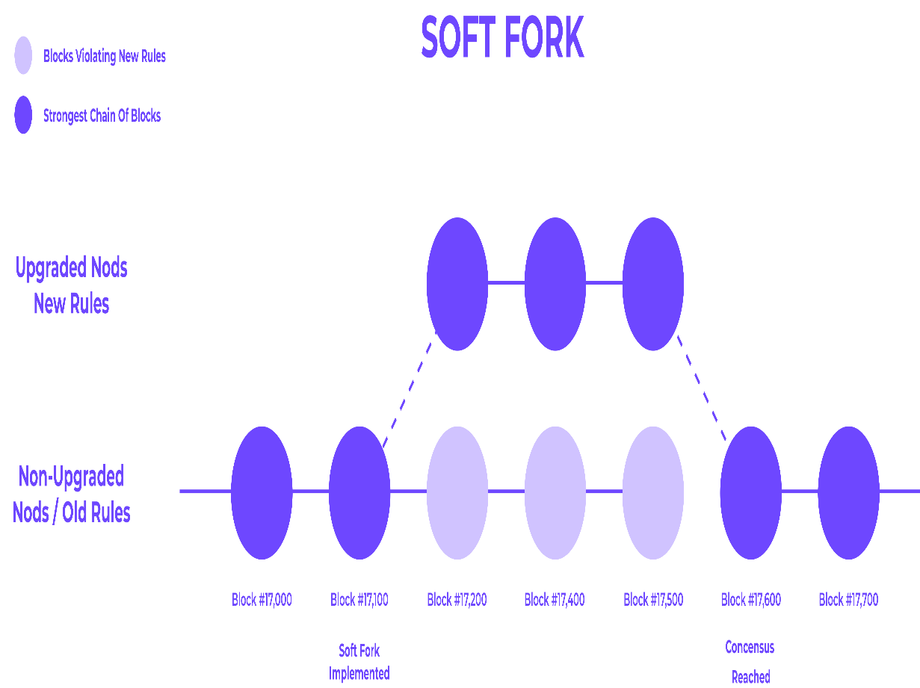Top of Form

Why do fork accureTop of Form

-

Forks occur when the software of different miners become misaligned. It's up to miners to decide which blockchain to continue using. If there isn't a unanimous decision, then this can result in the creation of two versions of the blockchain. There can be periods of increased price volatility around such events.

Why is this important

* Innovation: Forking allows developers to experiment with new features and improvements on existing blockchain protocols, without needing to start from scratch. This can lead to new and innovative blockchain technologies.
* Community Governance: Forking also allows blockchain communities to make decisions about the direction of their blockchain. If a significant portion of the community disagrees with the direction of the blockchain, they can fork the chain to create a new one with a different set of rules.
* Hard Fork vs Soft Fork: There are two types of forks, hard forks and soft forks. Hard forks result in a permanent split in the blockchain and create a new, separate chain. Soft forks, on the other hand, are backward-compatible upgrades to the existing chain. Both types of forks are important in their own ways, as they allow for different types of changes to be made to the blockchain.
* Consensus Mechanisms: Forking is also important in different consensus mechanisms used in blockchain, such as Proof of Work and Proof of Stake. In PoW, forks can occur when two miners solve the block at the same time, while in PoS, forks can happen when validators disagree on the current state of the blockchain.

Overall, forking is a crucial aspect of blockchain technology as it allows for innovation, community governance, and consensus mechanisms. However, it's important to note that forking can also lead to fragmentation of the community and confusion for users. Therefore, it should be used judiciously and with careful consideration.

* Top of Form

How blockchain works-

* Distributed Ledger: Blockchain is a decentralized and distributed ledger technology that enables the creation of a secure and tamper-proof digital record of transactions.
* Blocks: Transactions are grouped together into blocks and then added to the blockchain in a chronological order. Each block contains a cryptographic hash of the previous block, linking them together in a chain.
* Consensus Mechanism: A consensus mechanism is used to validate and confirm transactions, ensuring that they are legitimate and not fraudulent. Examples of consensus mechanisms include Proof of Work (PoW) and Proof of Stake (PoS).
* Cryptography: Cryptography is used to secure the blockchain by ensuring that only authorized users can access and modify the ledger. Public and private keys are used to authenticate users and ensure the integrity of the data.
* Immutable: Once a block is added to the blockchain, it cannot be altered or deleted. This makes the blockchain immutable and provides a permanent record of all transactions.
* Transparency: The blockchain is transparent, meaning that all users can view the transactions that have taken place on the network. This helps to ensure accountability and prevent fraud.
* Smart Contracts: Smart contracts are self-executing contracts that are stored on the blockchain. They can be used to automate complex business processes and eliminate the need for intermediaries.
* Decentralized Applications: Blockchain technology can be used to create decentralized applications (dApps) that run on the blockchain. These dApps are designed to be secure, transparent, and resistant to censorship.

Overall, blockchain is a revolutionary technology that is transforming the way we store and transmit data. Its decentralized and secure nature makes it ideal for a wide range of applications, from financial transactions to supply chain management.

* Top of Form

How to build a trust in blockchain technology?

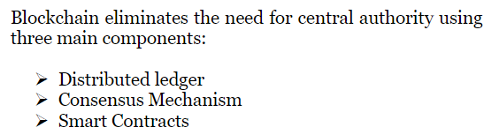

Distributed ledger database:

* Database that stores the current state and historical values of the data.
* The blockchain is an append-only, immutable database which has a cryptographic verifiable log of all tractions.
* All member have same copy of data.

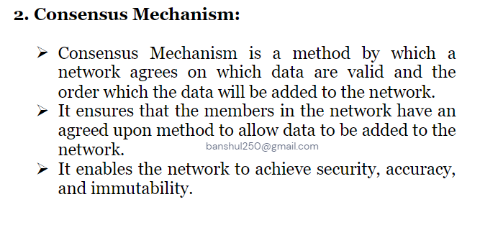

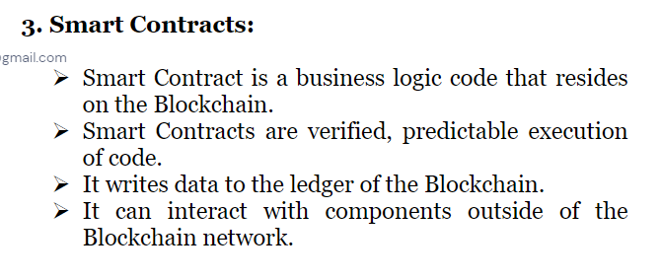

Blockchain potential application-

Here are some potential applications of blockchain technology in various industries:

* Finance: Blockchain technology can be used to create a more secure and transparent financial system. It can be used for cross-border payments, digital identity verification, and smart contracts that automate financial transactions.
* Supply Chain Management: Blockchain technology can be used to create a more efficient and transparent supply chain. It can be used to track goods from production to delivery, ensuring transparency and accountability in the process.
* Healthcare: Blockchain technology can be used to store and share medical records securely and efficiently. It can also be used for clinical trial management, supply chain management of pharmaceuticals, and drug traceability.
* Real Estate: Blockchain technology can be used to create a more transparent and efficient real estate market. It can be used for property title and ownership transfer, smart contracts for property management, and tracking property transactions.
* Voting: Blockchain technology can be used to create a more secure and transparent voting system. It can be used for voter registration, identity verification, and recording and counting votes.
* Energy: Blockchain technology can be used to create a more efficient and transparent energy market. It can be used for peer-to-peer energy trading, tracking of energy usage, and incentivizing energy-efficient behavior.
* Education: Blockchain technology can be used to create a more secure and decentralized education system. It can be used for secure storage of educational records and credentials, as well as for creating a more transparent and decentralized system of educational content creation and distribution.
* Top of Form

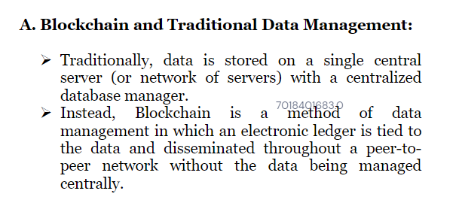

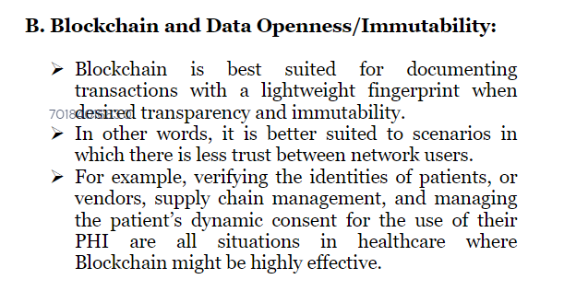

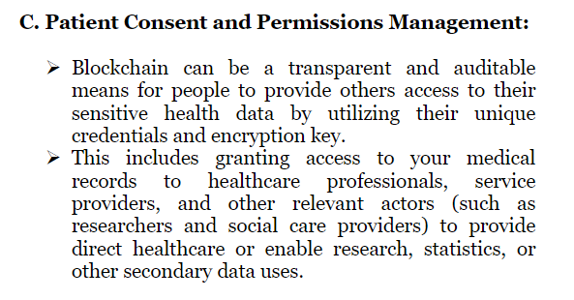

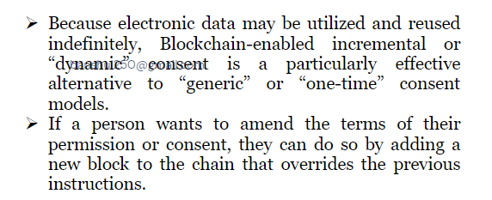

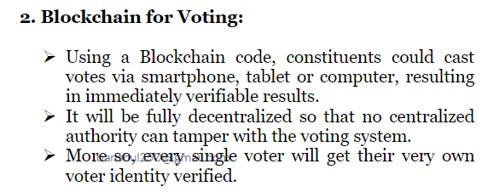

Blockchain in financial service-

* Digital Currency: Blockchain technology is the underlying technology behind cryptocurrencies such as Bitcoin and Ethereum, which are revolutionizing the financial services industry.
* Cross-Border Payments: Blockchain technology can be used to facilitate cross-border payments, reducing the time and cost associated with traditional methods.
* Smart Contracts: Smart contracts are self-executing contracts that are stored on the blockchain. They can be used to automate complex financial processes, such as settlement and clearing of trades.
* Know Your Customer (KYC): KYC processes can be time-consuming and expensive for financial institutions. Blockchain technology can be used to create a shared database of customer information, reducing the duplication of efforts.

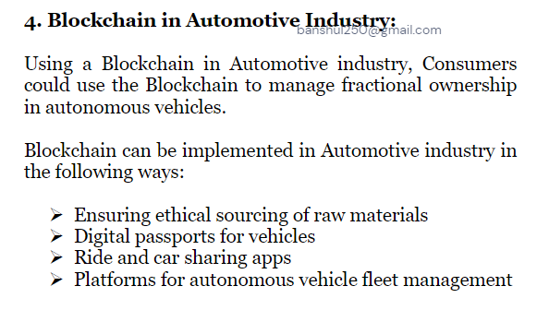

Types of nodes in blockchain-

* Full Nodes: Full nodes are the backbone of the blockchain network. They store a complete copy of the blockchain and are responsible for validating transactions and blocks.
* Light Nodes: Light nodes are a type of node that does not store a complete copy of the blockchain. They rely on full nodes to provide them with information about the blockchain.
* Mining Nodes: Mining nodes are responsible for adding new blocks to the blockchain. They perform complex mathematical calculations to validate transactions and add them to the blockchain.
* Masternodes: Masternodes are a type of node that is used in some blockchain networks, such as Dash. They perform specific functions, such as transaction validation, instant transactions, and voting on network governance issues.
* Super Nodes: Super nodes are a type of node that is used in some blockchain networks, such as EOS. They are responsible for validating transactions and blocks, as well as performing other network functions such as governance and voting.
* Seed Nodes: Seed nodes are the initial nodes that a new node will connect to when it joins the network. They provide the new node with information about the network and other nodes.

Overall, the different types of nodes in a blockchain network work together to ensure the security, transparency, and efficiency of the network.

* Top of Form

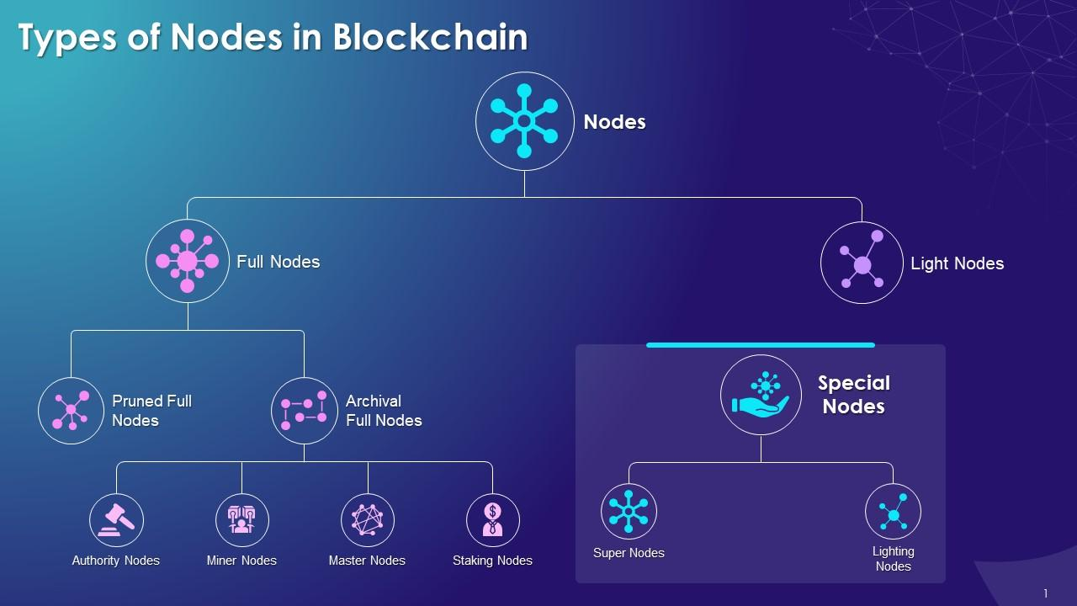

Consensus mechanism in blockchain

* Consensus is the process by which nodes in a blockchain network agree on the state of the network.
* In a decentralized blockchain network, there is no central authority to make decisions. Instead, nodes work together to reach consensus on the state of the network.
* Consensus algorithms ensure that all nodes on the network have a consistent and accurate view of the blockchain.
* Different blockchain networks use different consensus algorithms, such as Proof of Work (PoW), Proof of Stake (PoS), and Delegated Proof of Stake (DPoS).
* PoW is the original consensus algorithm used by Bitcoin. It involves nodes competing to solve complex mathematical puzzles in order to validate transactions and add new blocks to the blockchain.
* PoS is a newer consensus algorithm that requires nodes to hold a certain amount of cryptocurrency in order to participate in the validation process. This is believed to be more energy-efficient than PoW.
* DPoS is a consensus algorithm used by some blockchain networks, such as EOS. It involves nodes voting for "block producers" who are responsible for validating transactions and adding new blocks to the blockchain.
* Consensus is a critical aspect of blockchain technology, as it ensures that all nodes on the network have a consistent and accurate view of the blockchain.
* Top of Form
* Top of Form



The Byzantine Generals Problem is a classic problem in distributed computing and communication, which illustrates the challenge of coordinating a group of nodes that are connected through a communication network, but some of them may be unreliable or even malicious.

The problem is based on a hypothetical scenario where several generals of the Byzantine army are planning to attack a city. Each general commands a division of the army, and they must coordinate their attack plans to succeed. However, the generals are located in different parts of the country, and the only way they can communicate is by sending messages through messengers.

The challenge is that some of the messengers may be traitors, who could tamper with the messages, or even deliver false messages, in order to sabotage the attack plans. The generals need to come up with a strategy to ensure that they all agree on the same attack plan, even if some of the messengers are traitors.

To solve the Byzantine Generals Problem, the generals must agree on a common protocol that ensures that they all follow the same plan, regardless of the messages they receive. This protocol should have the following properties:

1. Agreement: all the generals should agree on the same plan.
2. Integrity: the protocol should ensure that the plan is not tampered with.
3. Validity: the plan should be a valid plan that the generals can execute.

Several solutions have been proposed for the Byzantine Generals Problem, including the Byzantine fault-tolerant (BFT) consensus algorithms, such as Practical Byzantine Fault Tolerance (PBFT) and Federated Byzantine Agreement (FBA). These algorithms use cryptographic techniques and redundancy to ensure that the generals can reach a consensus even if some of the nodes are unreliable or malicious.

Top of Form

Regenerate response

Difference between crypto coin and token-

Crypto coin-

Crypto coins and tokens are both types of digital assets that are used in blockchain-based systems, but there are some key differences between them. Here are some points outlining the main differences:

* Origin: Crypto coins are standalone currencies that have their own blockchain, while tokens are created on top of an existing blockchain. For example, Bitcoin and Litecoin are coins, while Ethereum-based tokens like ERC-20 tokens are tokens.
* Purpose: Coins are generally used as a means of payment or store of value, while tokens can have various functions, such as access to a service or product, voting rights, or representing a physical asset.
* Technology: Coins have their own blockchain and operate independently, while tokens are built on top of an existing blockchain and rely on its technology.
* Mining: Coins can be mined using specialized computer hardware, while tokens are not mined, but are created through a smart contract on an existing blockchain.
* Value: The value of coins is mainly determined by market demand and supply, while tokens are often tied to a specific project or company and their value is based on their perceived usefulness or potential for growth.
* Distribution: Coins are typically distributed through a mining process or an initial coin offering (ICO), while tokens are usually distributed through an initial coin offering (ICO) or airdrop.
* Regulation: Coins are often subject to more regulatory scrutiny than tokens, as they are seen as a form of currency, while tokens can have various functions and may not necessarily be subject to the same regulations.

In summary, while both coins and tokens are digital assets used in blockchain-based systems, they have different origins, purposes, technologies, methods of creation and distribution, and levels of regulation.



Crypto token-

Crypto tokens are digital assets that are created on top of an existing blockchain, usually as part of a larger project or ecosystem. Here are some points outlining the main characteristics of crypto tokens:

1. Blockchain-based: Crypto tokens are built on top of an existing Blockchain, such as Ethereum, Binance Smart Chain, or Solana. They rely on the underlying blockchain's technology, security, and consensus mechanisms.
2. Purpose: Crypto tokens can serve various purposes, such as representing a physical asset, providing access to a service or product, voting rights, or serving as a currency within a specific ecosystem.
3. Smart Contracts: Tokens are created using smart contracts, which are self-executing contracts with the terms of the agreement directly written into lines of code. Smart contracts can automate complex transactions and enforce the rules and regulations of a token's ecosystem.
4. Standards: There are different standards of tokens on various blockchains. For instance, the most popular standard on Ethereum is ERC-20, while Binance Smart Chain uses BEP-20, and Solana uses SPL.
5. Distribution: Tokens are usually distributed through initial coin offerings (ICOs), initial exchange offerings (IEOs), or airdrops, where users receive tokens for free. ICOs and IEOs are similar to traditional initial public offerings (IPOs), where investors can buy tokens at a discounted price.
6. Value: The value of tokens is determined by their perceived usefulness or potential for growth within their ecosystem. Market demand and supply, as well as the popularity of the underlying blockchain, can also influence the token's value.
7. Regulation: Token regulation varies by jurisdiction and can depend on the token's purpose and characteristics. Some tokens may be subject to securities regulations, while others may be considered a commodity or currency.

In summary, crypto tokens are blockchain-based digital assets that are created using smart contracts and serve various purposes within their ecosystem. They are distributed through ICOs, IEOs, or airdrops, and their value is determined by their usefulness and potential for growth.

Top of Form



* Top of Form

Type of crypto token-

There are several types of crypto tokens that are used for different purposes within their respective ecosystems. Here are some common types of crypto tokens:

1. Utility Tokens: These tokens are used to access a specific service or product within a blockchain ecosystem. For example, Golem Network Token (GNT) is a utility token that grants users access to the Golem supercomputing network.
2. Security Tokens: These tokens represent ownership in a physical or digital asset and are regulated by securities laws. They can represent ownership in real estate, company shares, or other assets.
3. Payment Tokens: These tokens function as a means of payment within a blockchain ecosystem. For example, Bitcoin (BTC) and Litecoin (LTC) are payment tokens that can be used to pay for goods and services.
4. Asset-Backed Tokens: These tokens represent ownership in a physical asset, such as gold or real estate. The tokens are backed by the asset's value and can be traded on a blockchain.
5. Governance Tokens: These tokens provide holders with voting rights in decision-making processes within a blockchain ecosystem. For example, MakerDAO's Maker (MKR) token holders can vote on changes to the platform's stability fee.
6. Non-Fungible Tokens (NFTs): These tokens are unique digital assets that represent ownership of a particular asset, such as art, music, or in-game items. NFTs are often used in blockchain-based games and marketplaces.
7. Stablecoins: These tokens are pegged to the value of a fiat currency or a physical asset to provide price stability within a blockchain ecosystem. For example, Tether (USDT) is pegged to the US dollar, and its value is always approximately equal to $1.

In summary, there are various types of crypto tokens that serve different purposes, such as providing access to a service, representing ownership in a physical or digital asset, functioning as a means of payment, or providing voting rights in decision-making processes. Understanding the different types of tokens is essential for investing and participating in blockchain ecosystems.

Top of Form

Regenerate response

Crypto token are used for-

